Cover Page

Table of contents

Introduction

SOPS

# ADMINISTRATOR

## Systems installation

1. **Required Materials**
   1. Laptop or Desktop
   2. Windows 10 and above operating system
   3. 500 + GB storage
   4. 8 GB RAM
   5. Core -i5 processor 1.3 GHz +
   6. 25-inch monitor for desktops – better view
   7. Local Area Network connections or Wifi (for use with tables and phone)
2. **Server and Database**
   1. Apache Server 2.4 and above
   2. Mysql-8.0.3-winx64 and above
3. Download Apache servers and MySQL from official websites or folder in the link and extract using unzip software. Download link: <https://drive.google.com/drive/folders/1L1a0NDPmEMZE7GNLnji4pAZPvSTxgoP-?usp=drive_link>
4. Install the server as an administrator by following the installation wizard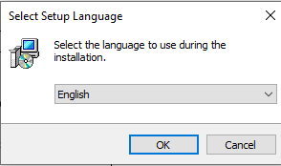
5. Click Next for installation to complete. Once it is installed. Close the application

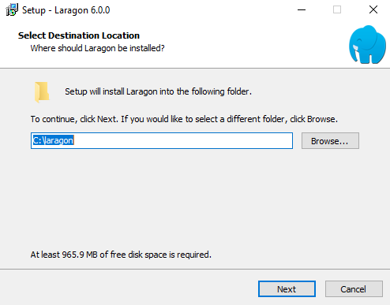

1. Confirm if Laragon or whichever server (XAMPP or WAMP) is successfully installed by checking in the taskbar or search panel.

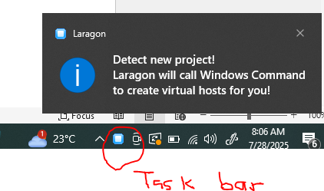

1. This level will require internet connection to download the phpMyAdmin and install along

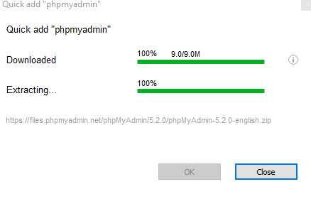

1. This will open this page: Username: **root**

Password: leave blank

Click Login

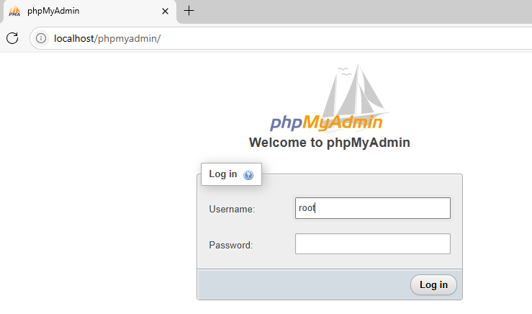

1. Download the project folders from <https://drive.google.com/file/d/1V8ywMDUk6NCiKcup9CaSP76vElru-WjK/view?usp=drive_link> and unzip to the laragon folder www or htdocs for XAMPP and give it your desired name example: **Methadone**



This PC > Local Disk (C:) > laragon > www > IORPMS

This PC > Local Disk (C:) > XAMPP > htdocs > IORPMS

1. This will open the following screen. Click on Databases and enter: **methadone** and choose **utf8mb4_general_ci** collation

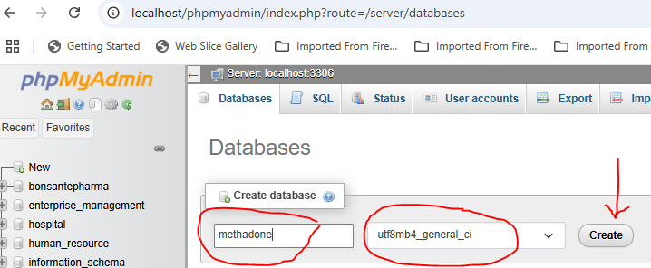

1. Import database from the folder C:/laragon/www/IORPMS/backup/database/iorpms.sql

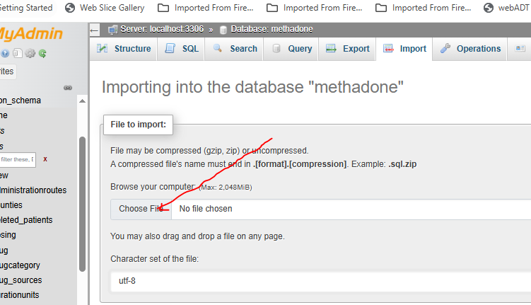

Type the following in url and press enter key <http://localhost/iorpms/>

1. This will open the following screen

Username: admin

Password: 123456 and login

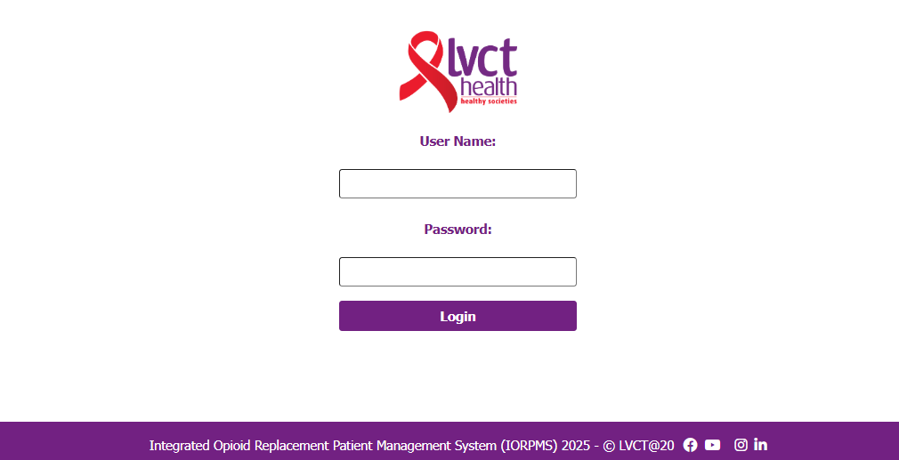

1. This will open the following landing page which is home page:

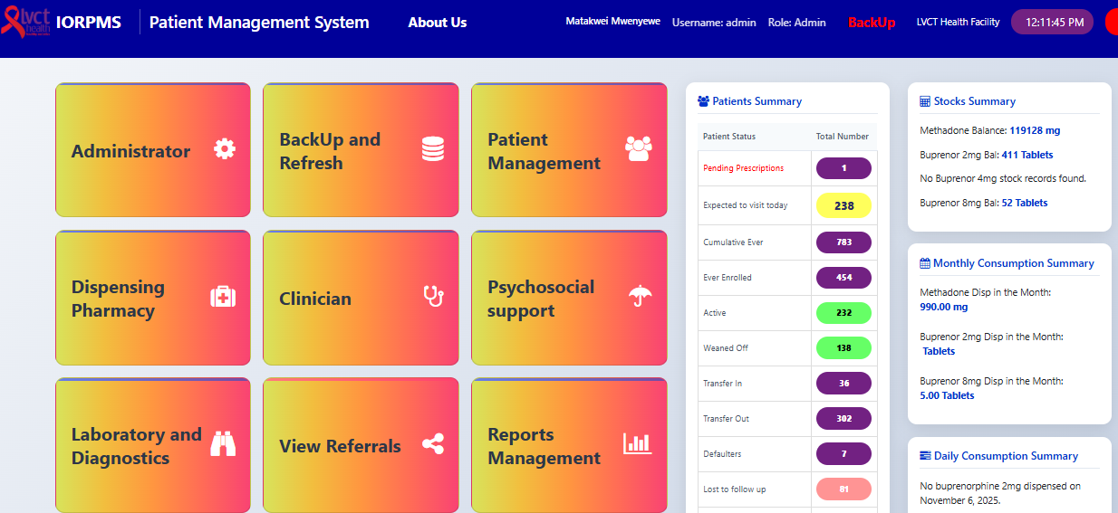

Disclaimer: You can now navigate to the module of interest. Not all users will see all modules

## Facility initial setup

1. Open Administrator module by clicking on it as shown is Systems installation procedure 13.
2. Go to facility setup

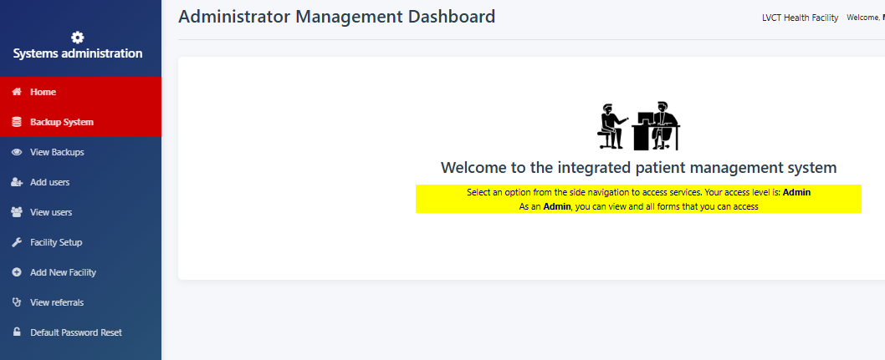

1. Select the facility and other settings will auto-populate and then fill in the facility in charge, phone and email and save and submit

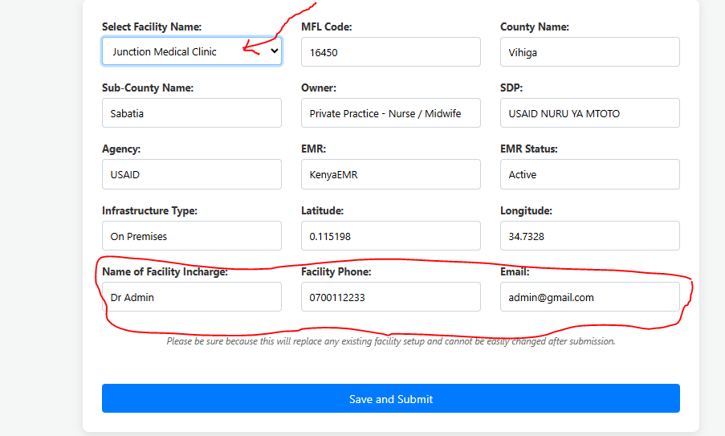

1. Click home to navigate back to home page and you should see the facility name displayed:

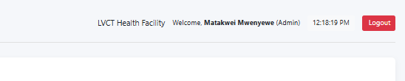

## Backups

1. Open Administrator module by clicking on it as shown is Systems installation procedure 13.

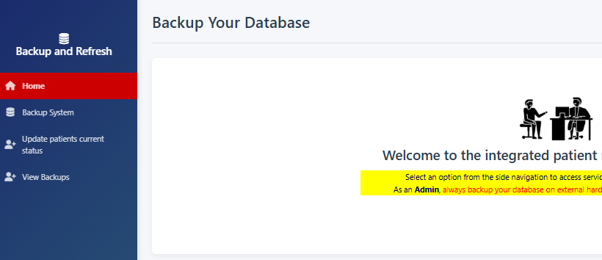

1. Click on backup system and you should see success message
2. Click view backups to see if the backup for the date is available

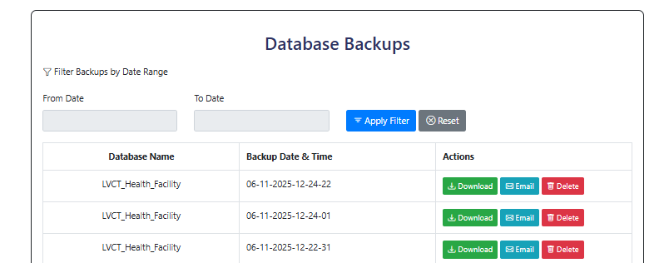

1. Click on download button to download the backup into the downloads folder
2. Click email to email the backup to the default email setup – still under development

## Add users

1. Click view users and search the name of the user you want to add

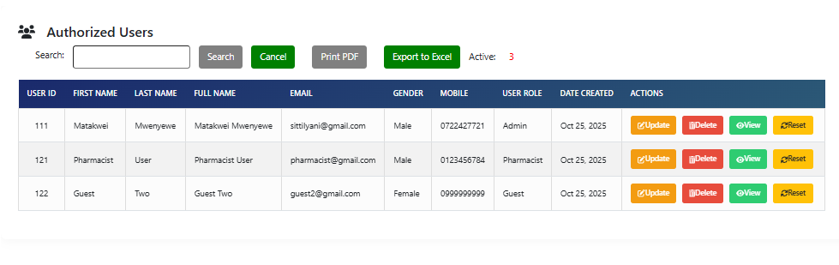

1. If the user doesn’t exist then, then click Add Users tab

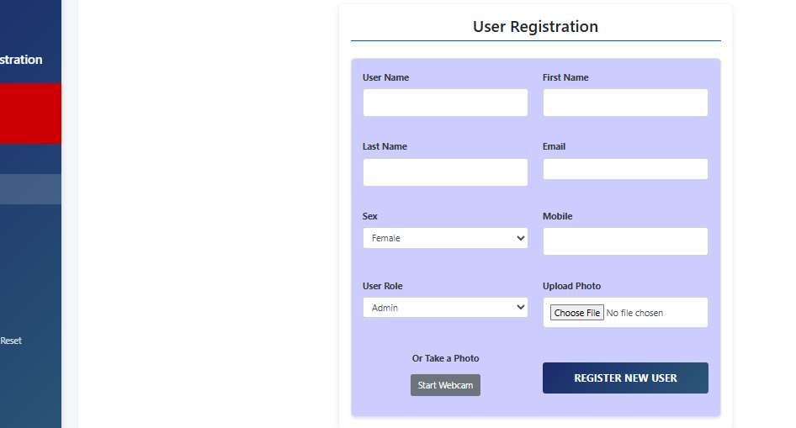

1. Input all required fields and submit by clicking ‘REGISTER NEW USER’ button
2. The system will automatically logout and you need to log in again

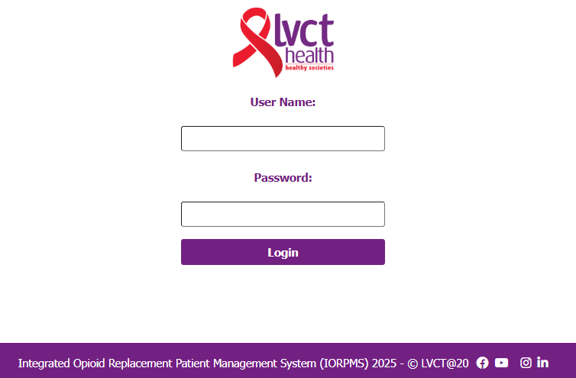

1. Enter your created username and default password “123456” to login again

## Change password

1. Login the system and select profile module
2. Click change password tab. Input 123456 as old password and input your preferred password and confirm by entering the same as new password and click update password

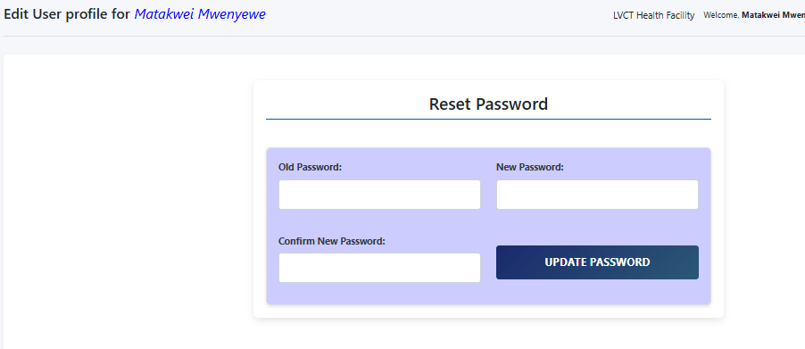

## Referrals

1. Click on view referrals to see all referrals submitted to different departments

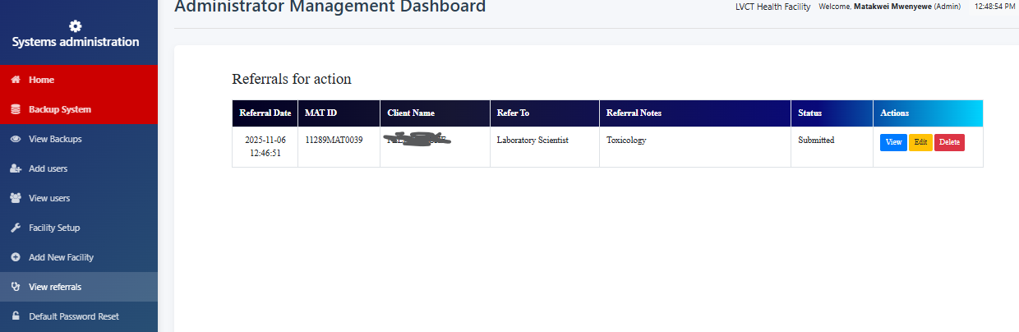

1. Click view to see the prescription details. The submitted date prompts for action.

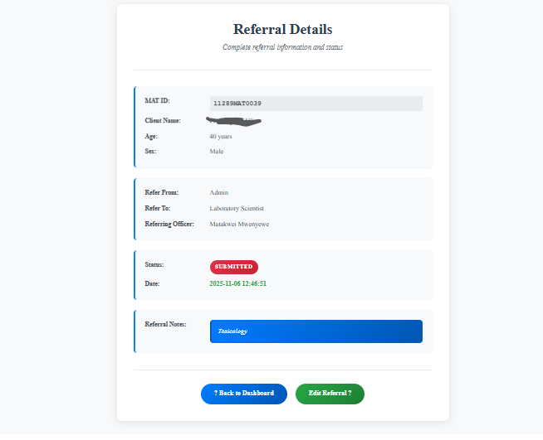

1. Delete button deletes the referral
2. View button displays the referral foe review or complete status

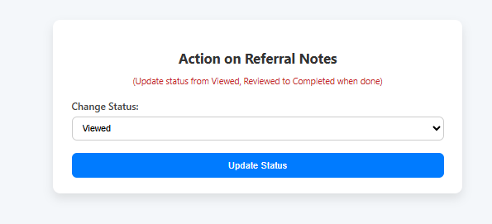

## Password resets

1. Click on the Default Password Reset tab to open the following:

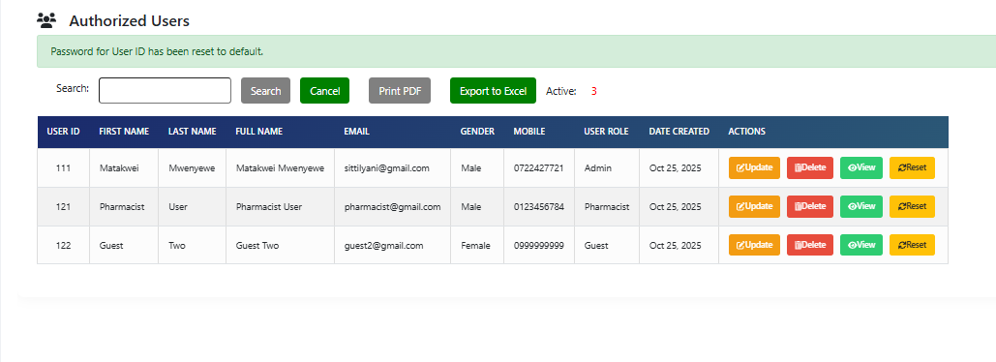

1. Update button updates the user details except the username

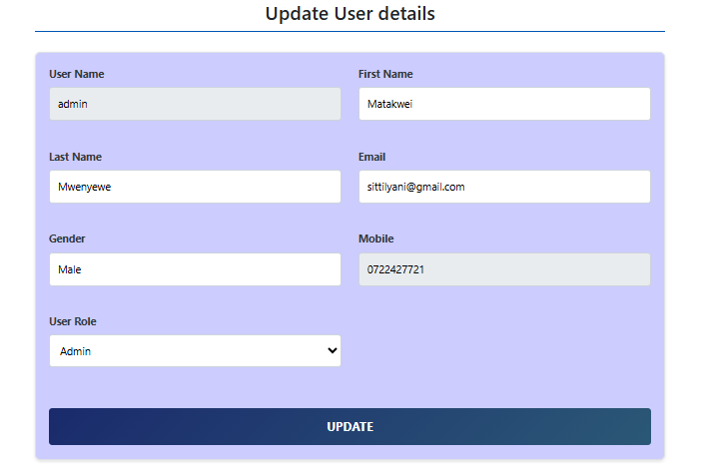

1. View button views the user details and you can navigate back to users’ list
2. Reset button resets the user password to **“123456”**

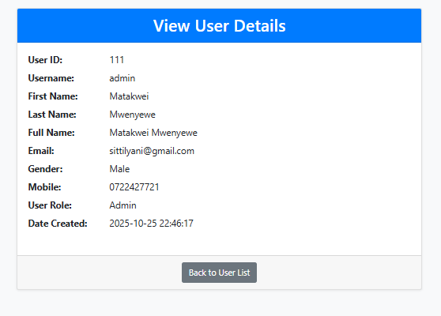

# BACKUP AND REFRESH

## Backup System

1. Open Administrator module by clicking on it as shown is Systems installation procedure 13.



1. Click on backup system and you should see success message
2. Click view backups to see if the backup for the date is available



1. Click on download button to download the backup into the downloads folder
2. Click email to email the backup to the default email setup – still under development

## Update patients’ current status

1. Click on update patients’ current status if the system was not on and you will see output like this below

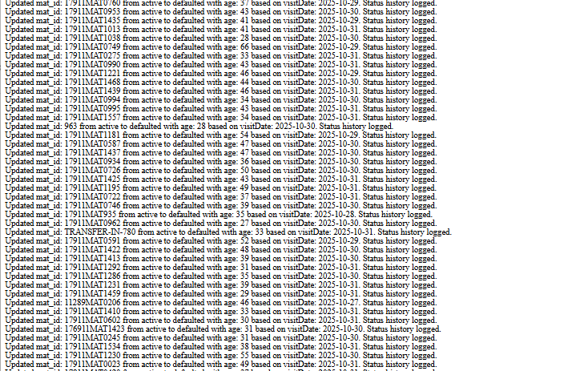

Active Patients who had missed more than 5 doses will change to defaulters

Defaulters who have missed more than 25 days from the day of default will change to LTFU (lost-to-follow-up)

## View backups

1. Click view backups to see if the backup for the date is available



1. Click on download button to download the backup into the downloads folder
2. Click email to email the backup to the default email setup – still under development

# PATIENT MANAGEMENT

1. Select the patient management module from the landing page

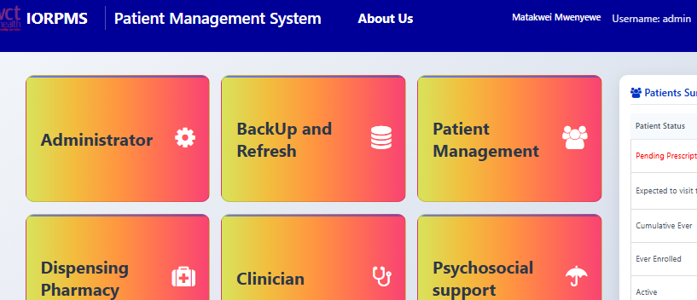

## Register New Client

1. Click on the Register New Client tab to open the following

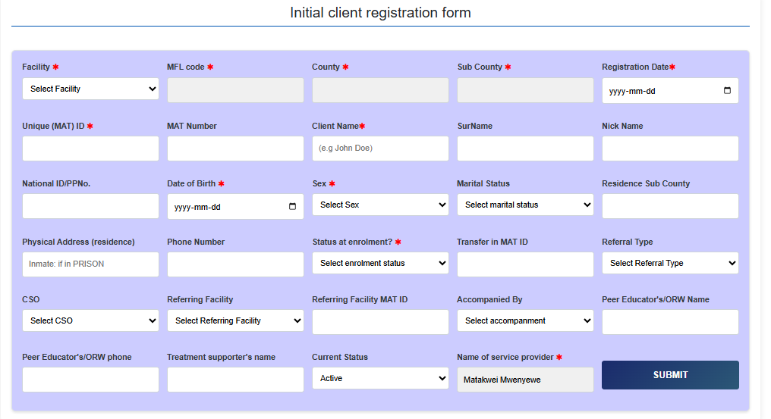

1. Select facility name from drop down
2. The MFLCode, County, Sub will auto populate from the database
3. Select registration date which can’t be in future
4. Unique MAT id uses MFLCode – MAT- 00001 or as per the clinic Standard operating Procedure example for LVCT Health clinic 99999MAT00001 where 99999 is MFLCode for Client number 00001
5. For Transfer In clients use their existing MAT ID Number
6. Client Name is example ‘John Doe’
7. Select Date of Birth which should be at least 15 years
8. Select sex
9. Fill the Physical address – if the clients is in prison - **INMATE**
10. Select enrolment status
    1. **New** is Induction
    2. **Transfer In** for clients from other facilities already on Methadone or Buprenorphine
    3. **Transit** is for those clients who will be taking methadone or buprenorphine for not more than 30 days and go back to their MAT facilities
11. Fields marked with asterisks are mandatory but if the registering officer has time, please update all fields
12. The unfilled fields can be updated later

## View Clients categories

1. Click on each category to view the number and details of patients in each category. Example below for ever-enrolled clients

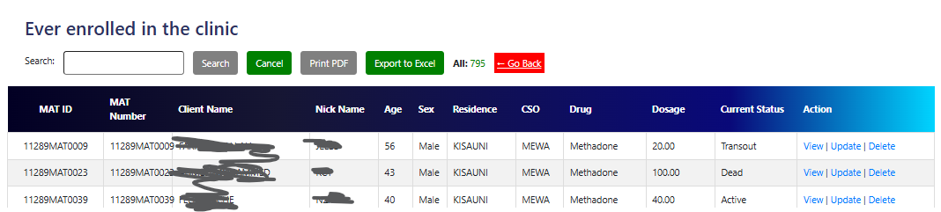

1. Current status shows the status of the client at that time e.g. dead, transfer out, weaned etc
2. View displays client details with photo if taken

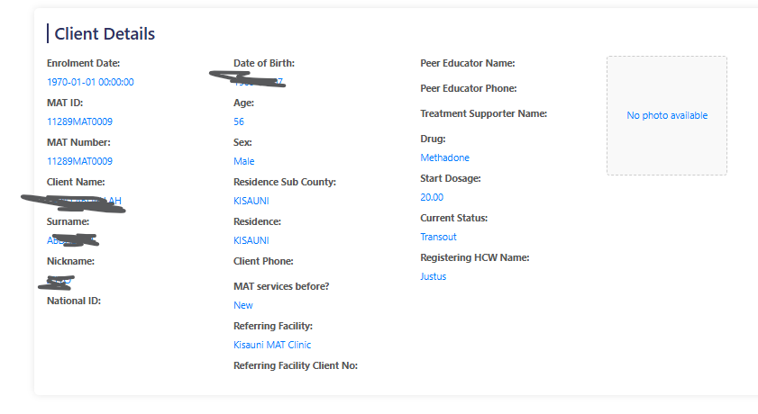

1. The update button opens the patient profile to edit

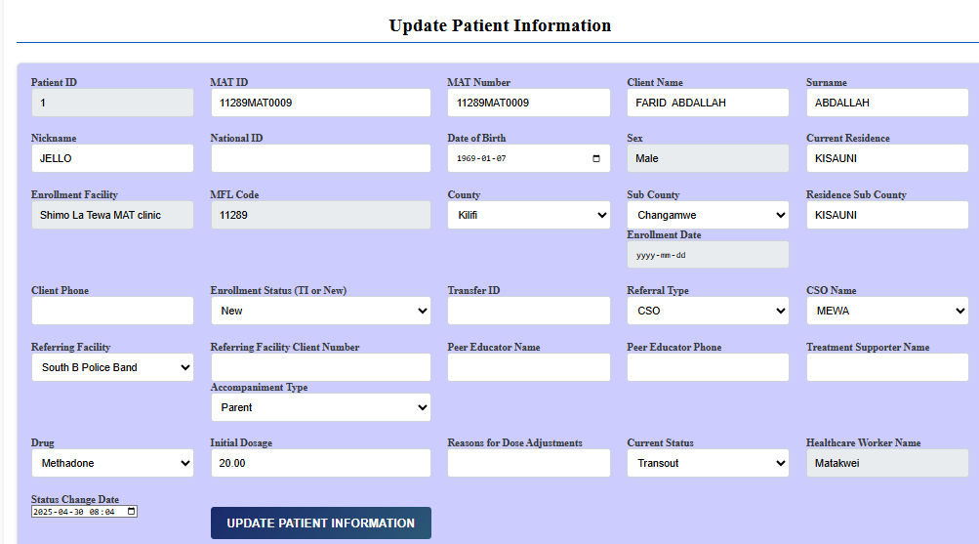

1. Delete button deletes the patient from database records.

## View other clients’ categories

1. The procedure is the same as above:

* **All patients:** Total clients including weaned, stopped, transfer out etc
* **Active:** On methadone or buprenorphine for the last 30 days
* **Lost To Follow UP:** missed drugs for more than consecutive 30 days
* **Weaned off:** Clients tapered off and voluntarily transition out of methadone or buprenorphine
* **Transfer Out:** Clients who received methadone or buprenorphine but have moved to another clinic spanning more than 30 days formally
* **Voluntary discontinuation:** Clients who have requested and consented to voluntarily stop taking methadone or buprenorphine before the formal weaning off
* **Defaulted:** Clients who have missed methadone or buprenorphine from more than five consecutive days
* **Transfer In:** Clients admitted in the clinic but was taking methadone or buprenorphine in another clinic and will be there for more than 30 days
* **Transit:** Clients admitted in the clinic but was taking methadone or buprenorphine in another clinic and will be there for less than 30 days
* **Inmates:** Clients taking their medication from prisons department
* **Dead:** Clients who succumbed by whichever cause
* Stopped: Involuntarily removed from the MAT program for one or several prescribed reasons

## View patient status change history

1. Click on “View patient status change history” to display the figure below

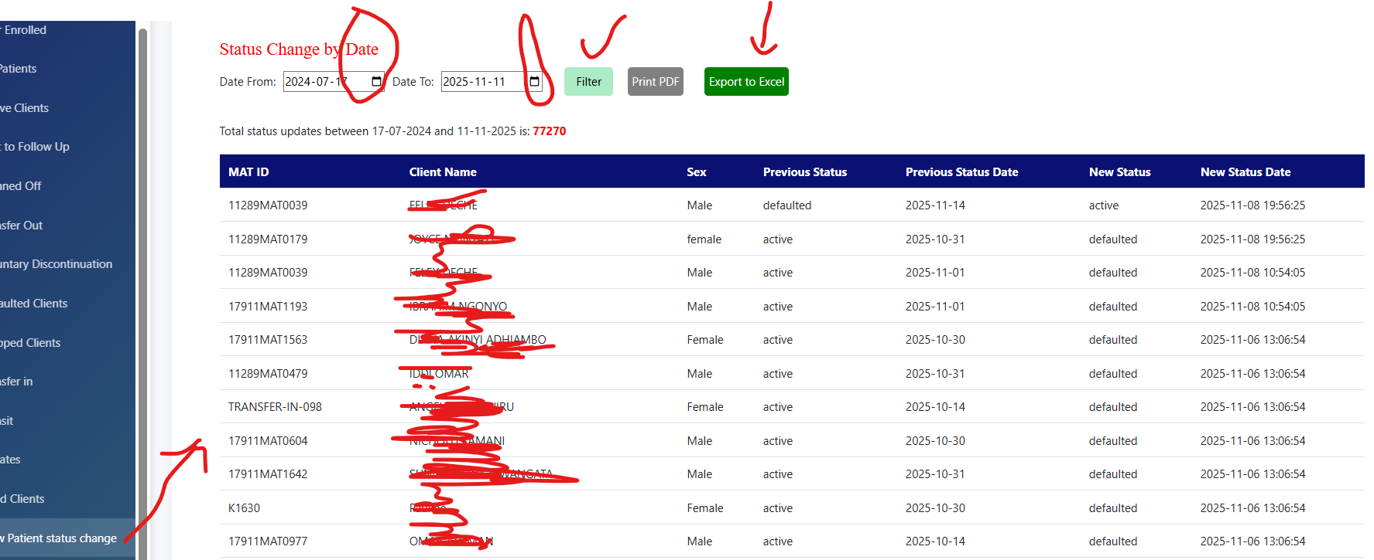

1. Select the date range (start Date and End date). Default is the current date
2. Click filter to display the patients who changed status on the selected date
3. “Print pdf” to print the PDF document for download or saving

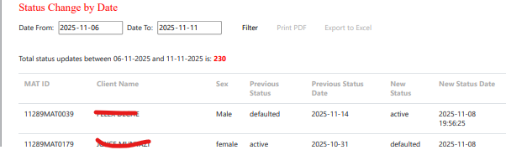

1. “Export to Excel” to export the status change statuses for the select dates

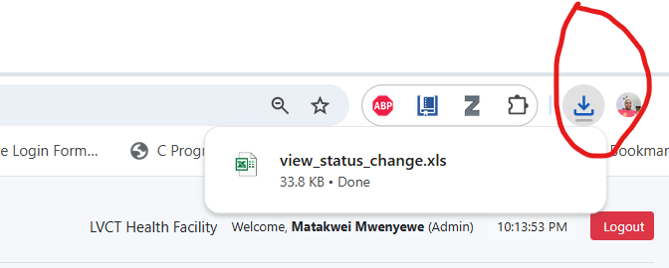

1. Click on the downloads folder by pressing CTLR + J to view in folder
2. Double click the downloaded file to view

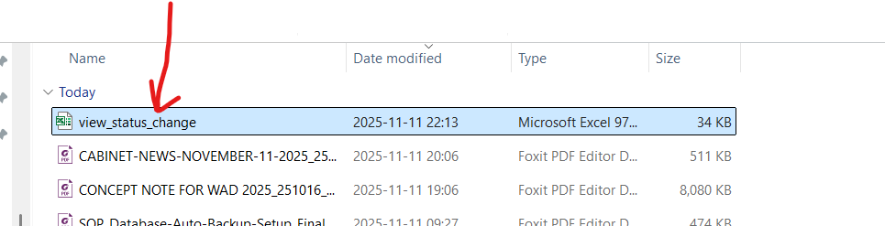

1. Click “Yes” to proceed with display

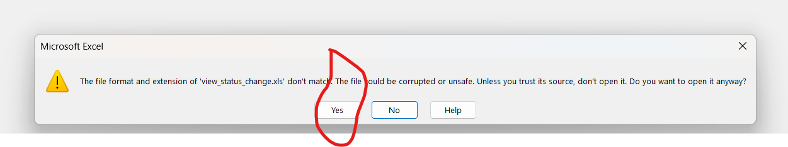

1. The output will be like the file below. Save the file for reference

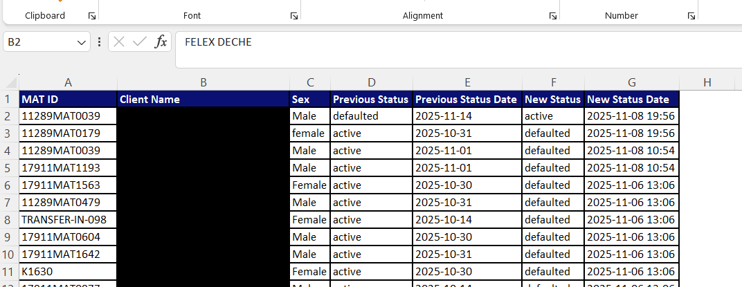

1. Close and exit

## HIV viral Load updates

1. Click on the “HIV viral Load updates” to display the table below

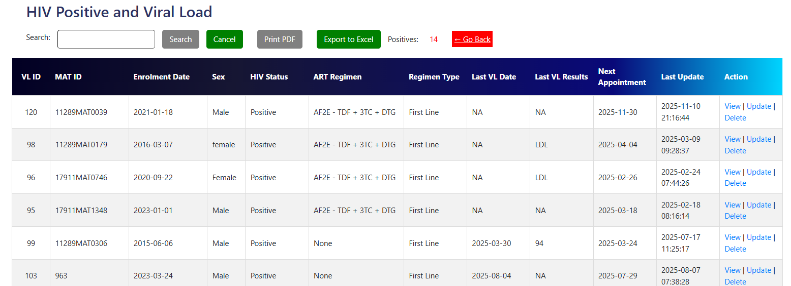

1. Search for the client to update viral load results and date
2. “View” button displays the viral load results

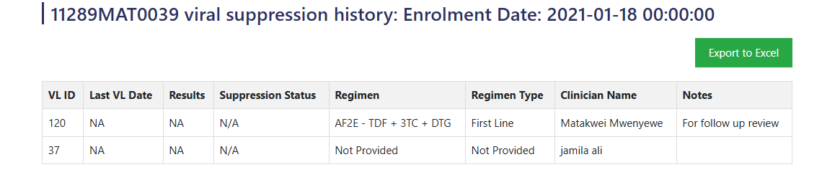

1. “Update” displays the clients details as shown below

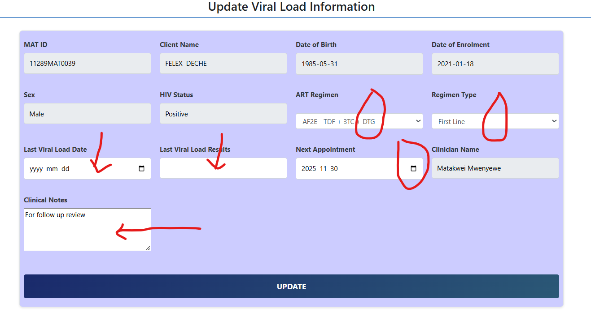

1. change the ART regimen if it has changed by selecting from the dropdown
2. Change the regimen Type if it has changed by selecting from the dropdown
3. Change the viral load date if there are any changes
4. Input the viral load results as numbers e.g. **1000001** **NOT** 1,000,001
5. Select the next appointment date from the date picker
6. Write any clinical notes, if none “NA”
7. Click “Update” and wait for success message

# DISPENSING PHARMACY

1. Access the pharmacy module by clicking on ‘Dispensing Pharmacy’ on the dashboard

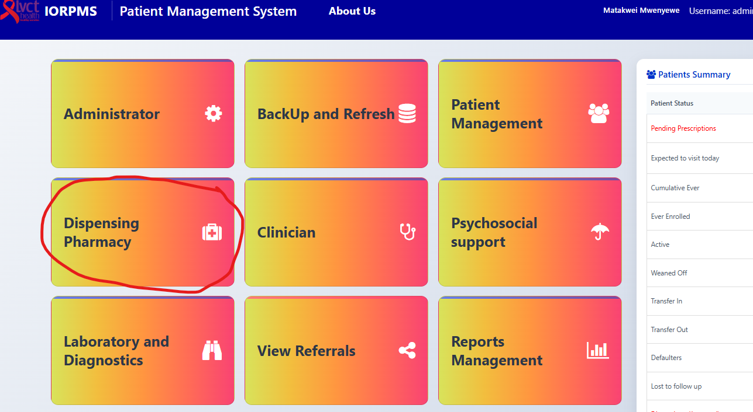

1. Navigate to specific sections as below:

## Dispense without pump – Buprenorphine

1. Click the ‘Dispensing without pump’ to open the search window

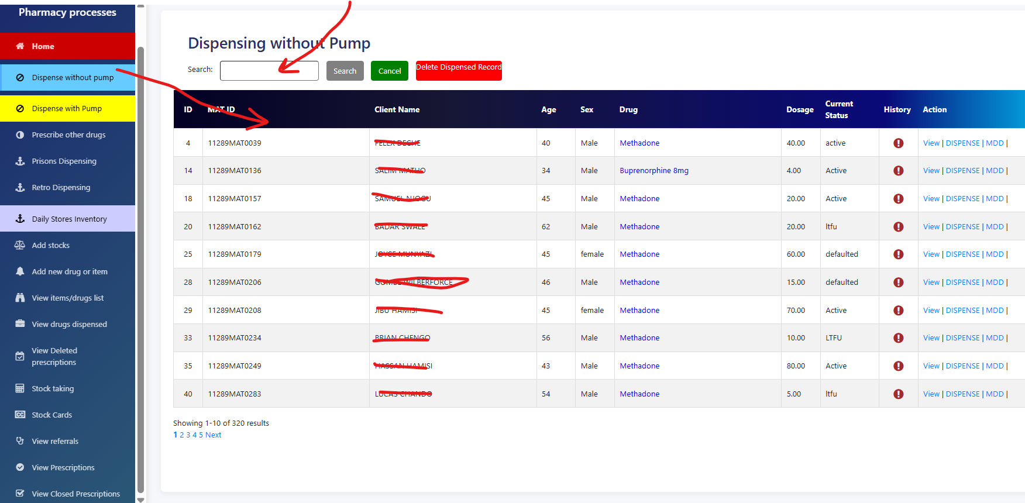

1. Type the client’s name, or MAT ID to find the patient. Clients identify themselves by their MAT IDs or Full Name
2. Click on History icon to view the patient dispensing history

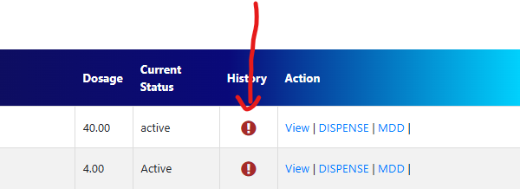

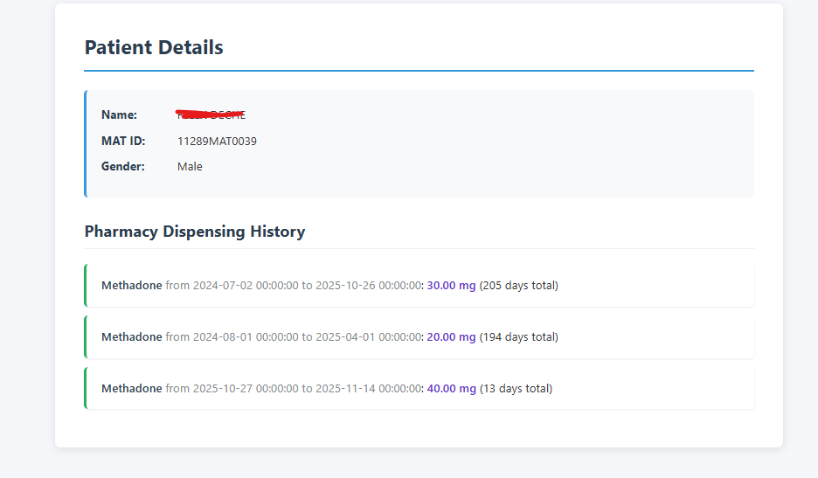

1. Click on the ‘Dispensing’ to open the dispensing window for a particular client

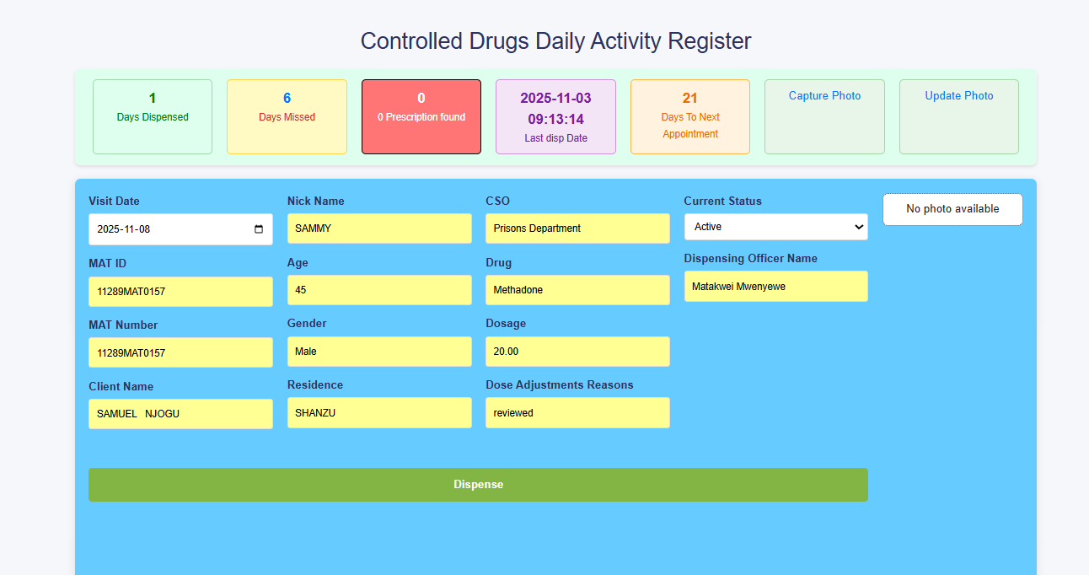

1. Confirm the dose, photo and once the right patient is present, click the green button ‘Dispense”
2. Wait for the success message. If successful will return to search window after 2 seconds for the next patient
3. The system will give error for the following:
   1. When the clients’ current status is NOT ‘Active’
   2. When the is no ENOUGH stocks in the dispensing system
   3. When the client dosage in ZERO
   4. If ‘Days to Next Appointment’ is ZERO
4. If there are other prescriptions alongside Methadone or Buprenorphine, they will display in the red display-card and at the bottom of the CD prescription

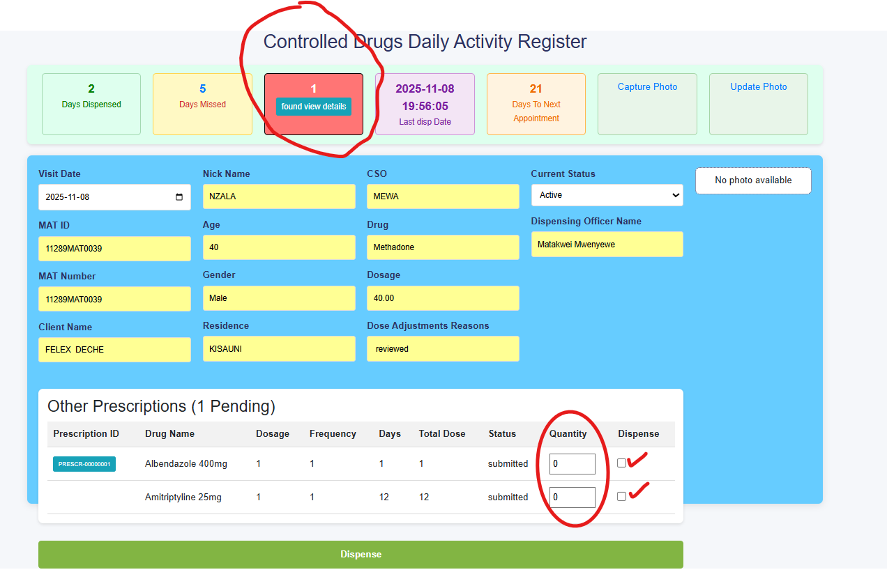

1. When the ‘Days to Next Appointment’ is ZERO, click on “Refer”

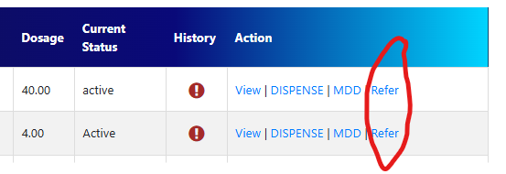

1. Select Clinician from the ‘Refer’ to adjust the dose or give the next appointment
2. In put the referral notes and send the client to clinician for review

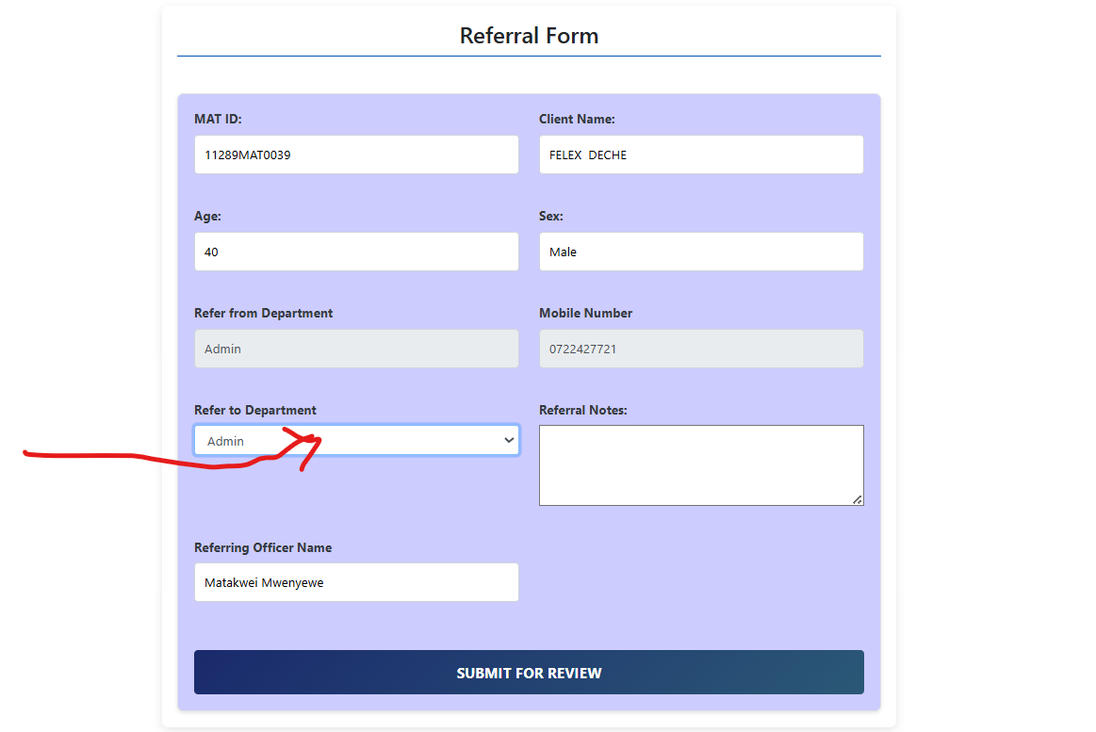

1. Also refer if missed appointment is More than 3 Days even if the client has a ‘Next Appointment’

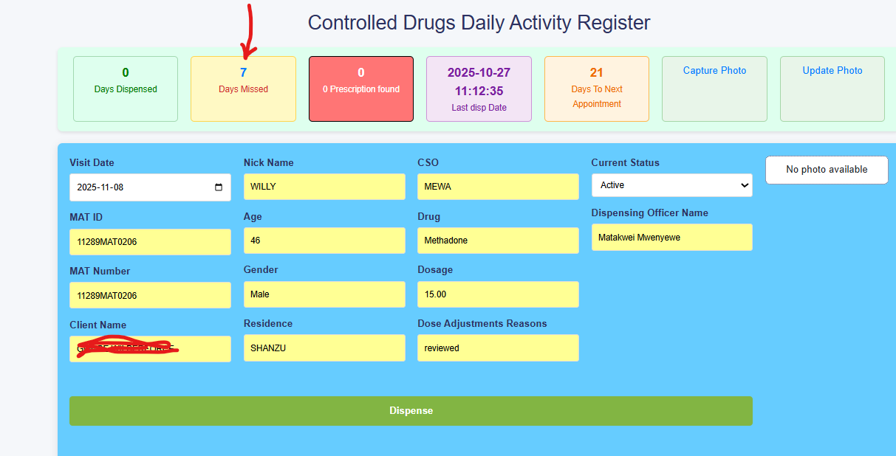

1. Click on the days missed to display the exact days missed

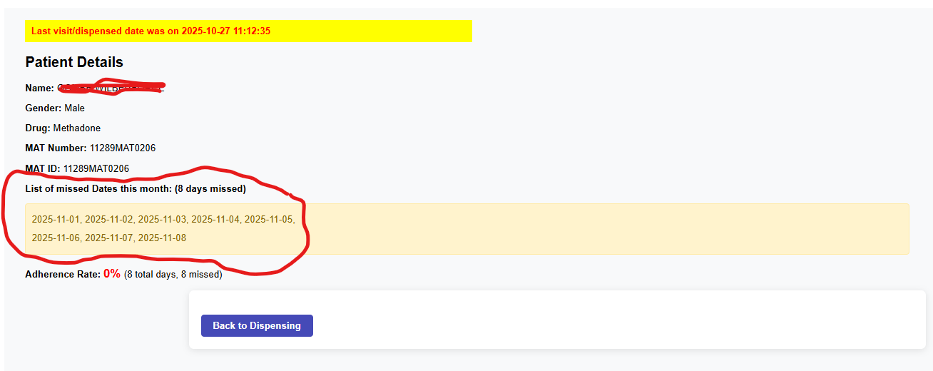

## Multi-Day Dispensing

1. Click on the MMD to display select the name of the client(s)

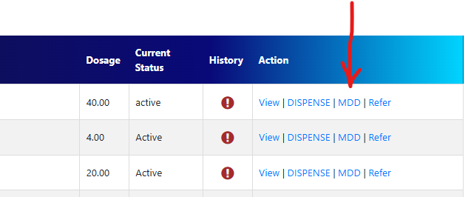

1. This will open the window below

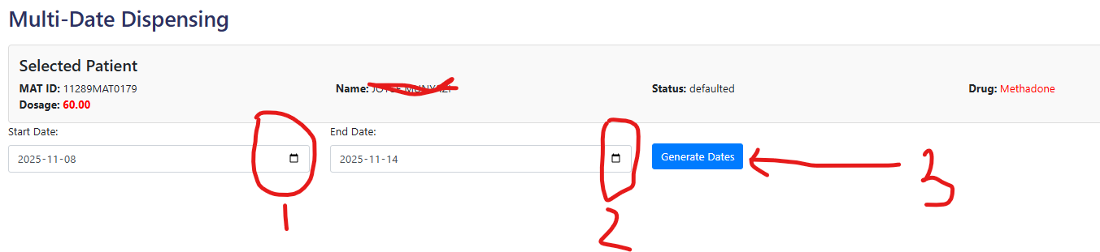

1. Select the start date, end date and click ‘Generate Date’ as shown below

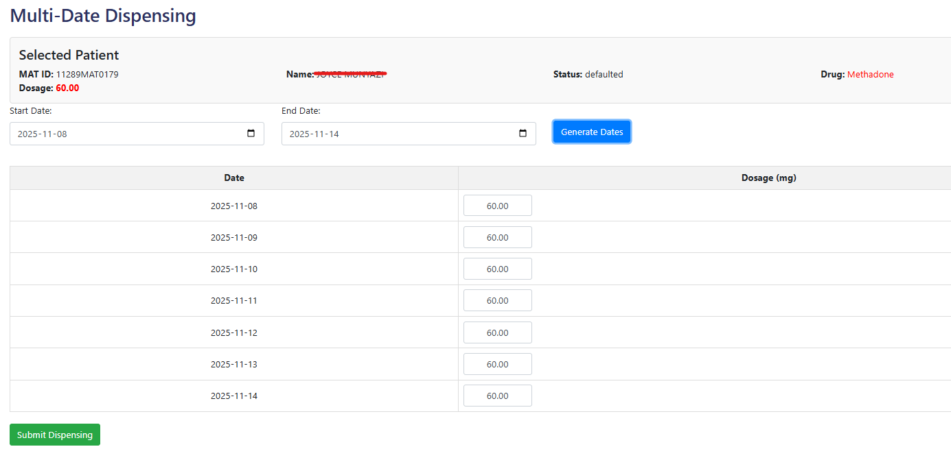

1. For the patients taking alternate doses, delete the days that should not be dispensed and click **‘Submit dispensing’**
2. Wait for the success message.
3. This is used to dispense for multiple days if the patient missed entries into the system due to system downtime or power failure.

## Dispense with pump – Methadone

1. Repeat the procedure as for Dispense without pump

## Prescribe other drugs

1. Click the prescribe other drugs and search for the client’s name. Once the client appears click prescribe

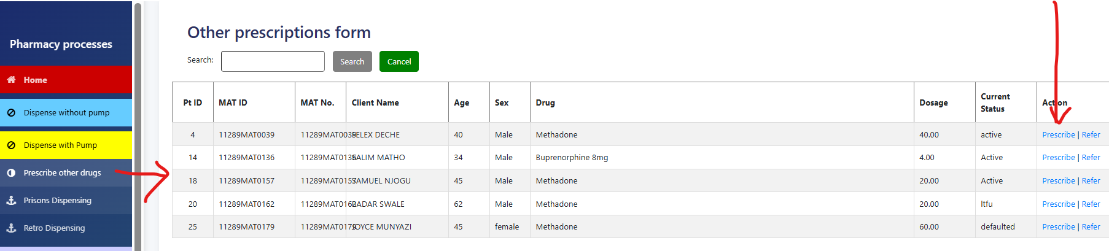

1. Select the drugs from the drug name drop down
2. Insert dosing, frequency and total days
3. The total dosage will auto-update
4. Click ‘Add drug’ to add the prescription to the cart
5. Repeat procedure 3 -5 if more drugs are prescribed
6. Press “save prescription’ once all drugs are added

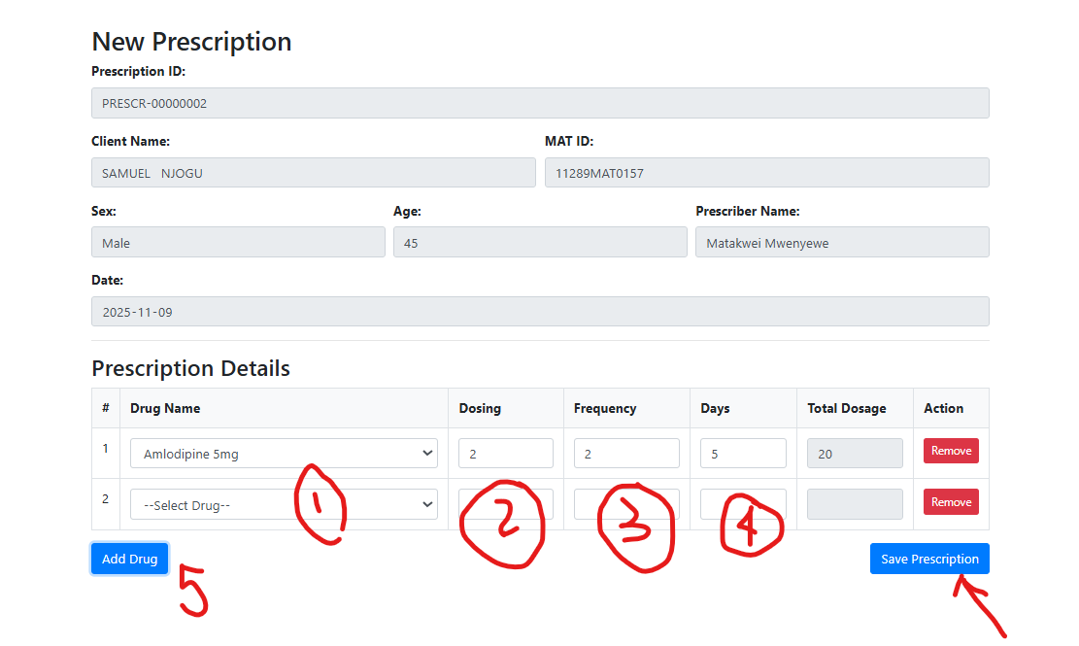

## Prisons dispensing

1. Click on ‘Prisons dispensing’ to open the window below

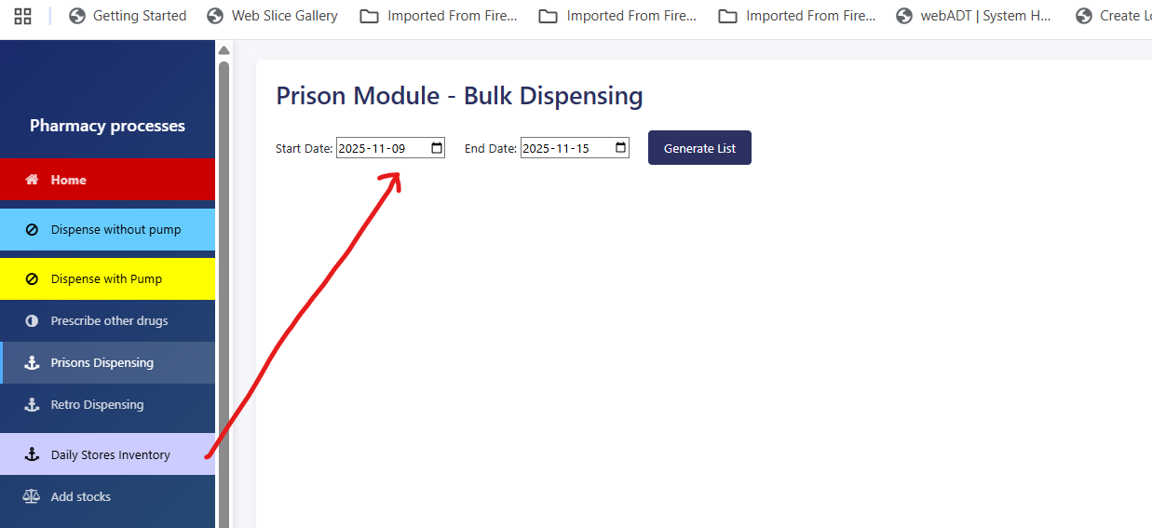

1. Select the date range and click generate List to generate a list of all clients in the prisons department who require Prisons delivery

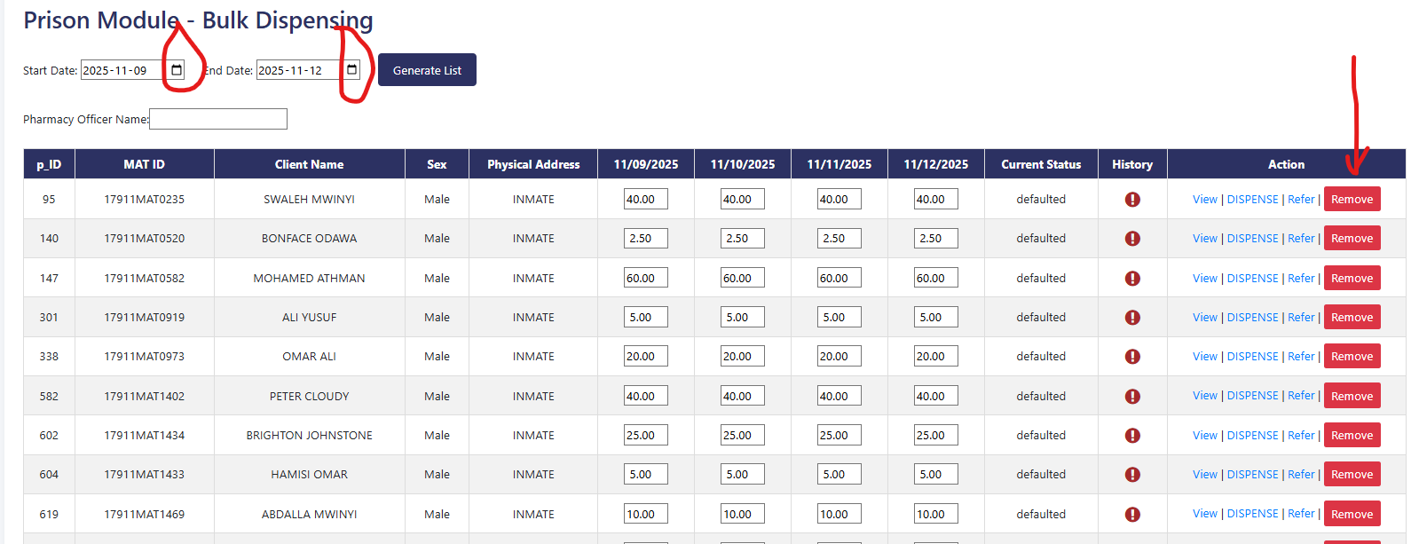

1. Click remove buttons to remove those clients not required
2. Input the ‘Pharmacy Officer Name’ delivering the doses to prison and press “Bulk dispensing”

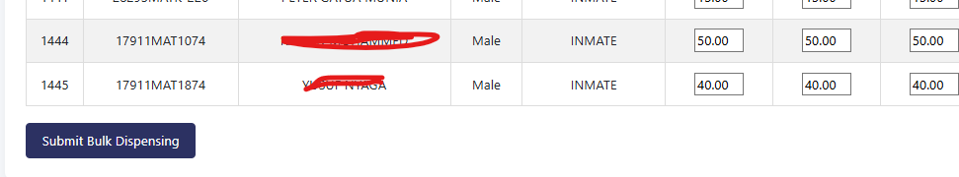

1. Wait for the success message by scrolling the page to the top, wait for at least 30 seconds
2. A summary of all dispensed doses will be displayed

## Retro-dispensing

1. Performance the procedure like in the prisons dispensing

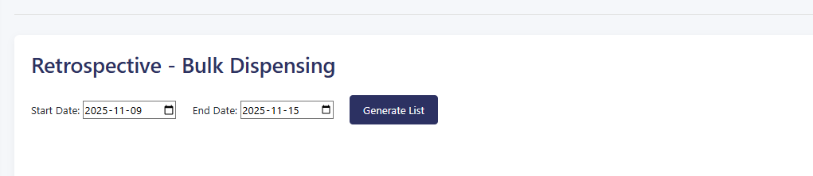

1. This procedure is done for already dispensed doses that were not documented in the system due to hardware or power failure

## Delete dispensed doses

1. Click on “Delete dispensed doses” to open the window below

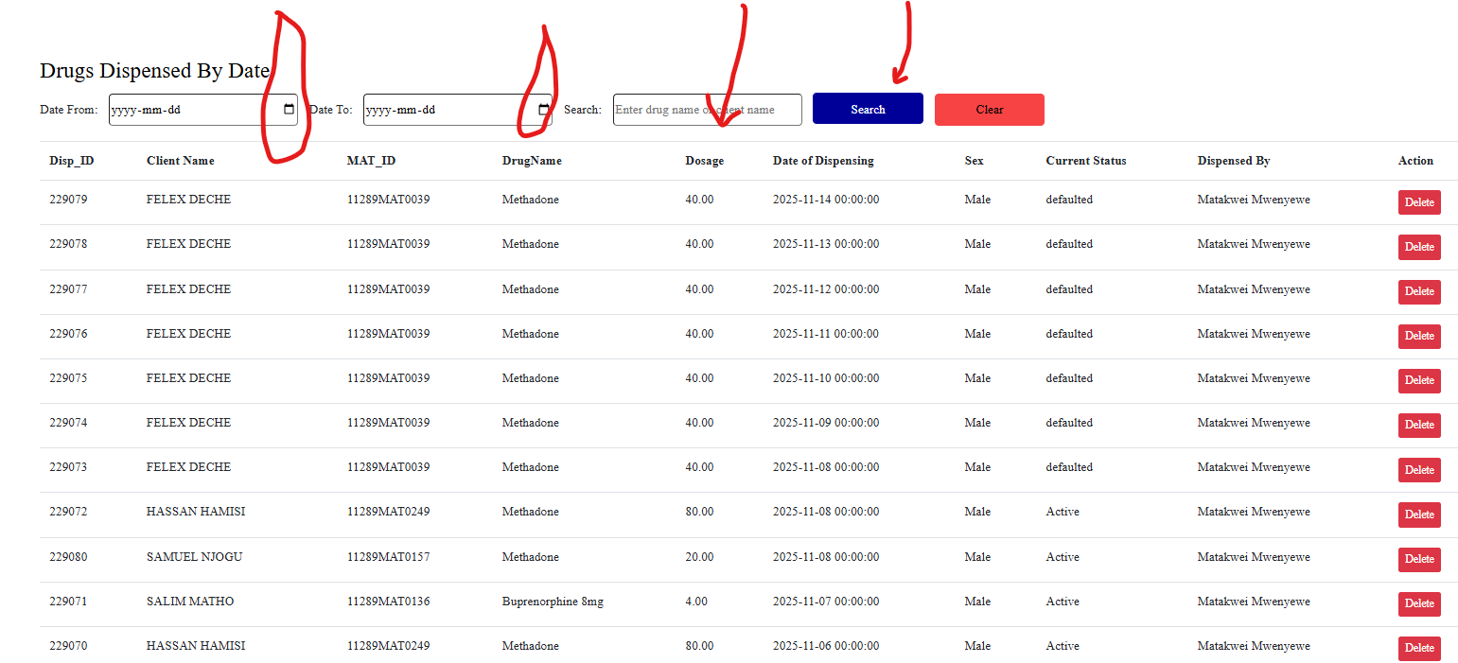

1. Select the date range to search for the prescription or the client name and press “Search”
2. Once the client Name is found, click on Delete

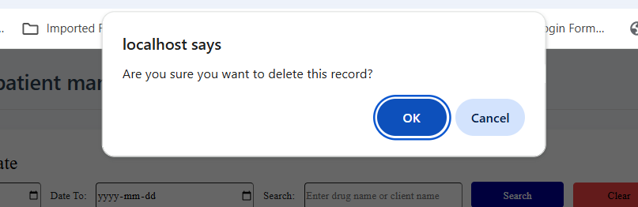

1. Press ‘OK’ once you are certain to proceed
2. Insert the reason for deleting the prescription at the bottom of the page and click “Confirm deletion”

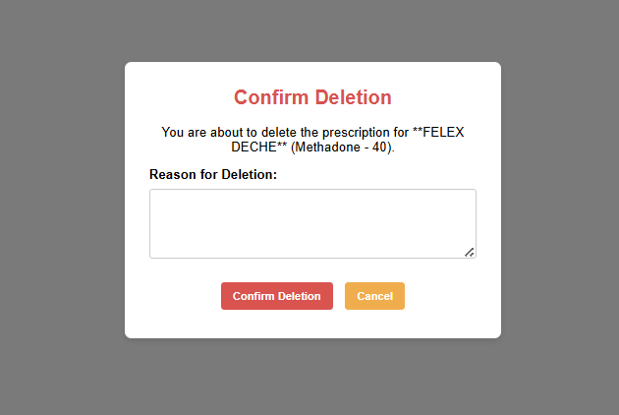

1. Wait for success message below

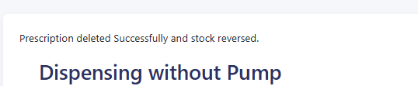

1. The page will redirect to dispensing
2. Press “Home” to go to dashboard

## Daily stores inventory

Click on the Daily stores inventory to access the daily transactions from stores to dispensing area

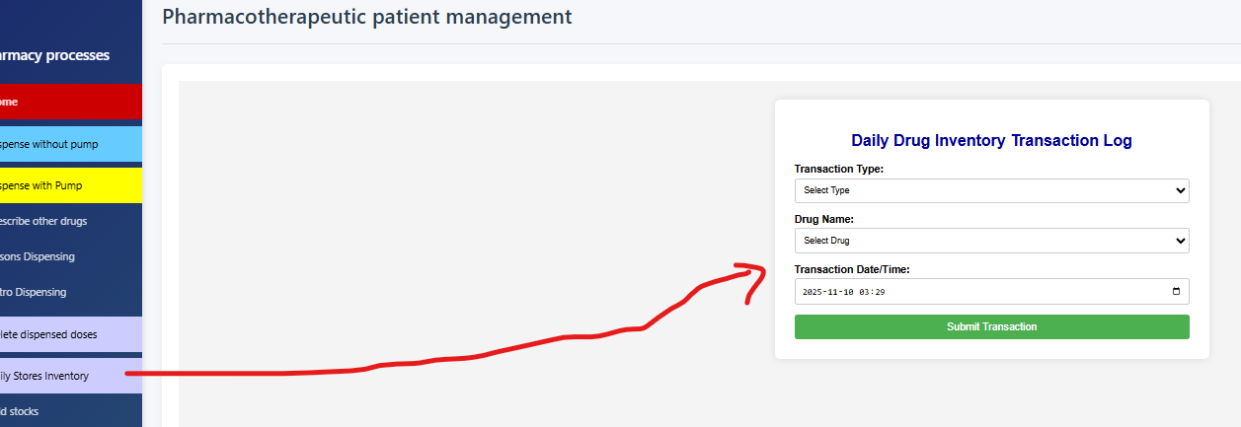

Select the transaction type, **‘Issue to dispensing area’**

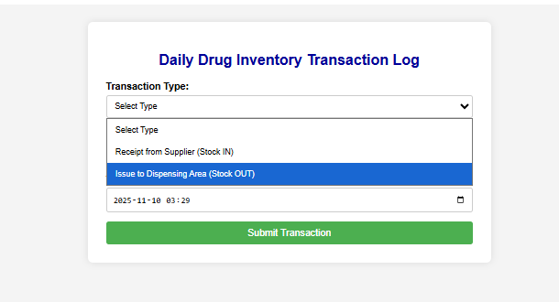

Select the drug e.g. Methadone

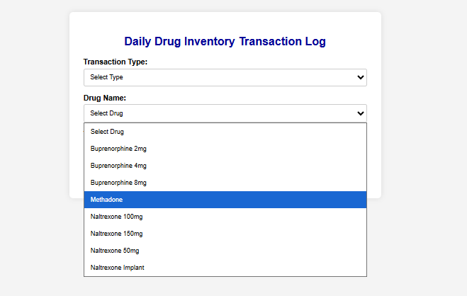

Enter the quantities to transfer from stores to dispensing area

Select the Issuer – staff releasing the stock

Select the receiver – staff receiving the stock in the dispensing area

Submit the transaction and wait for success message

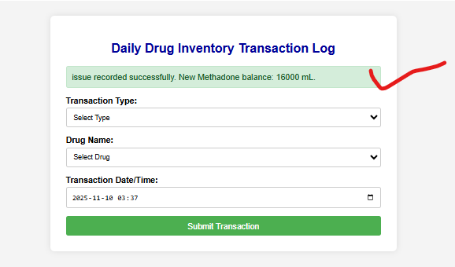

## Add stocks

1. Click on “Add stocks” to open the window

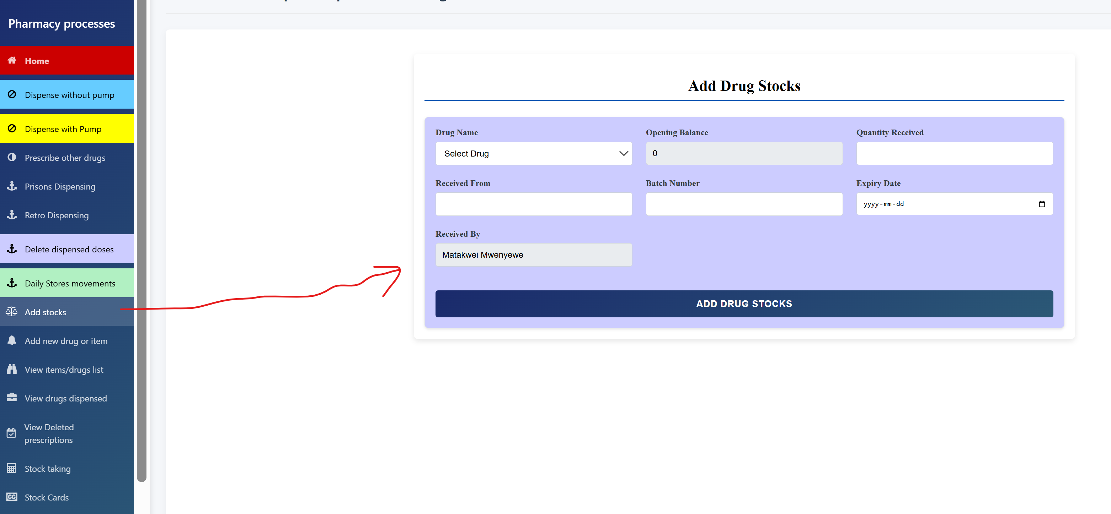

1. Select a drug to add to stores from suppliers by typing once you click in the drop down as shown below

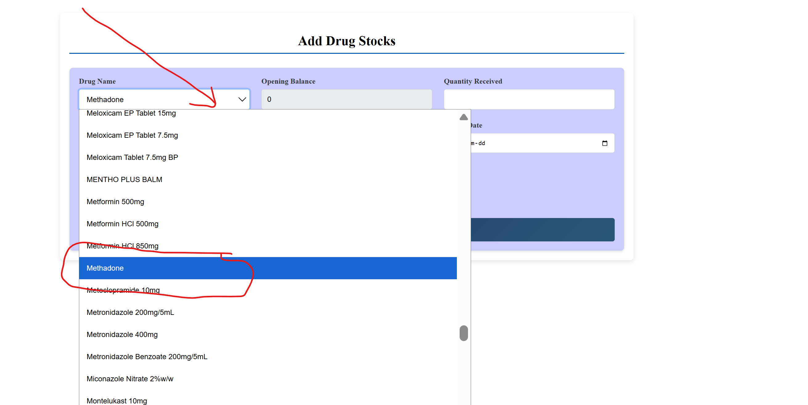

1. Input the quantity received in dispensing unit e.g mL, bottle, tablets etc
2. Enter the name of the supplier e.g. KEMSA
3. Enter the Batch No. e.g. 12345-KEMSA
4. Enter the expiry date which should be an expiry after the current date

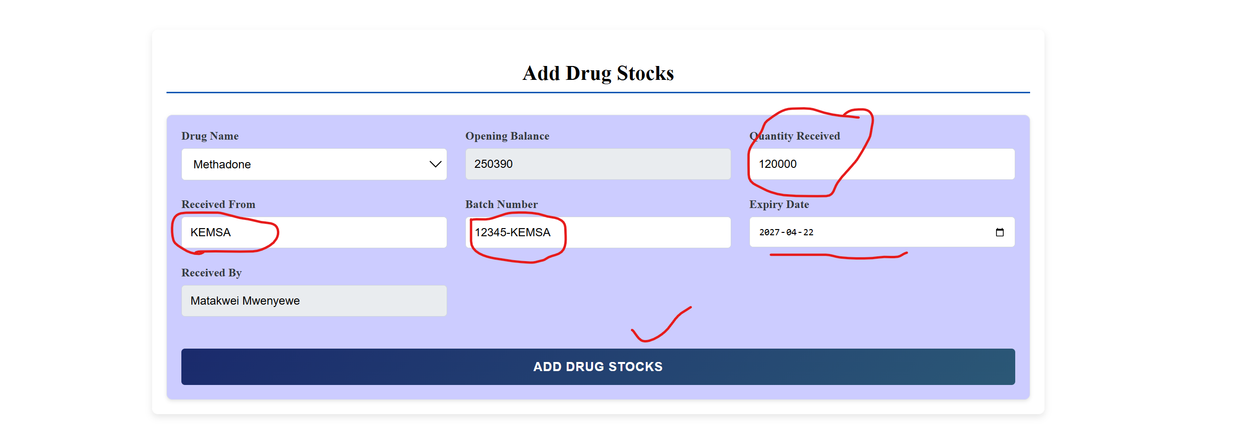

1. Click “Add inventory stock”
2. Wait for success message

## Add new drug or item

1. If the item is not available when adding items in stock, click on “Add new drug or item” to open the window below

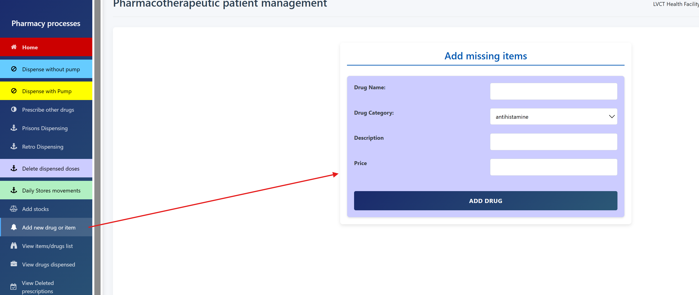

1. Input the following:
   1. Item name,
   2. category,
   3. description and
   4. price.

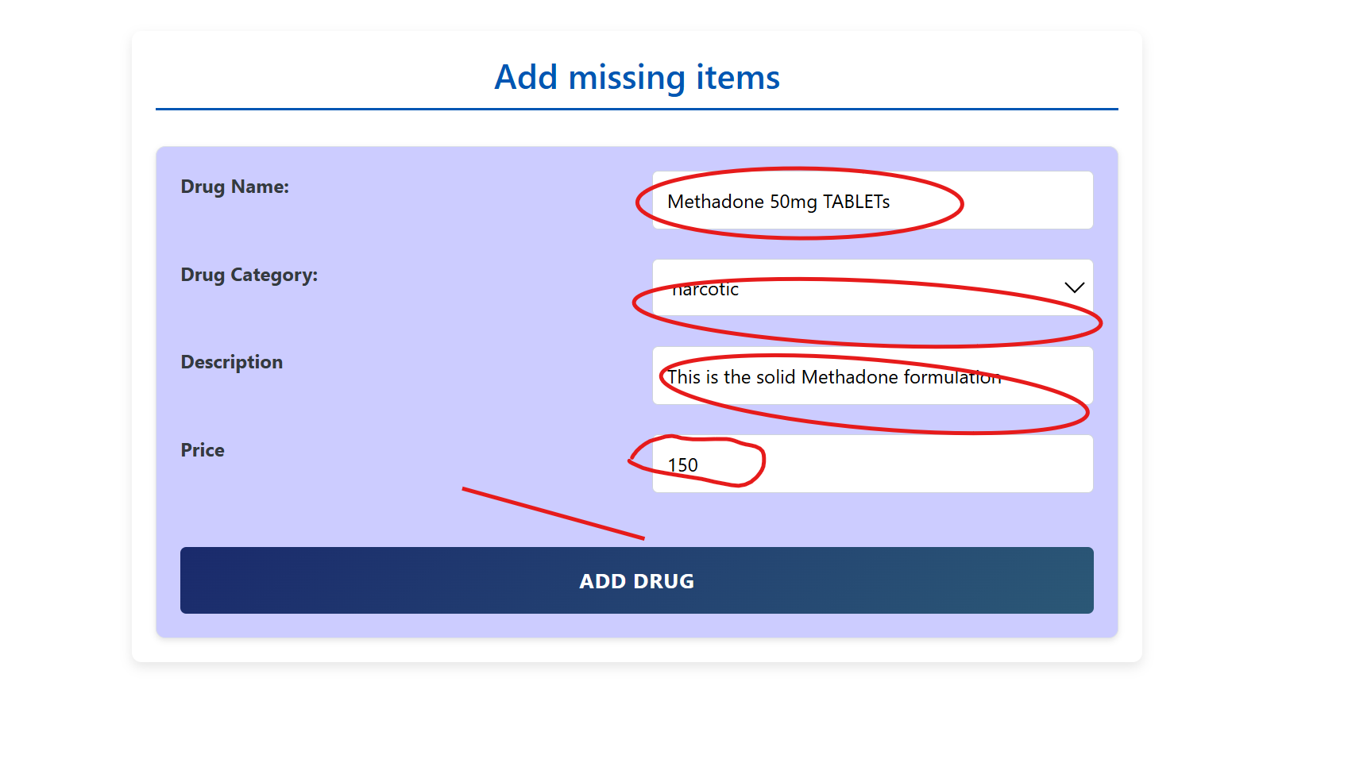

1. Click Add item to submit and wait for success message

## View items/drugs

1. Click view items/drugs list to view all items in the database

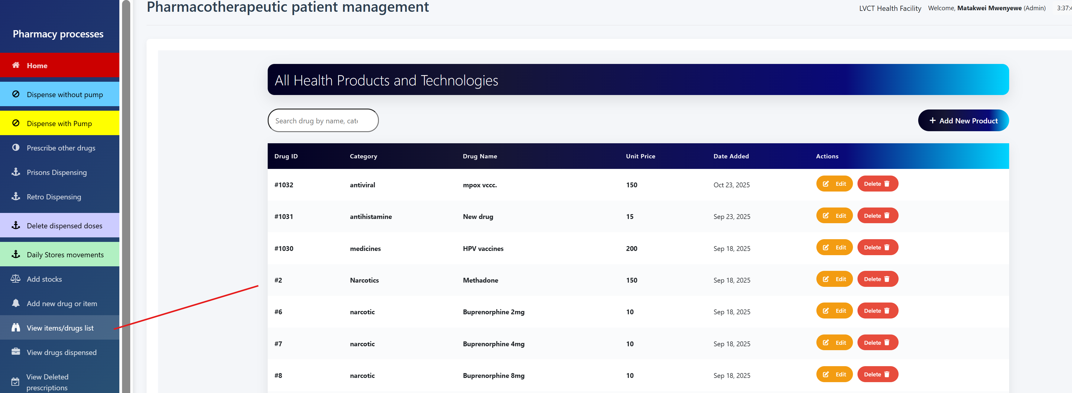

1. Type in the search bar to find the item in question example Naloxone

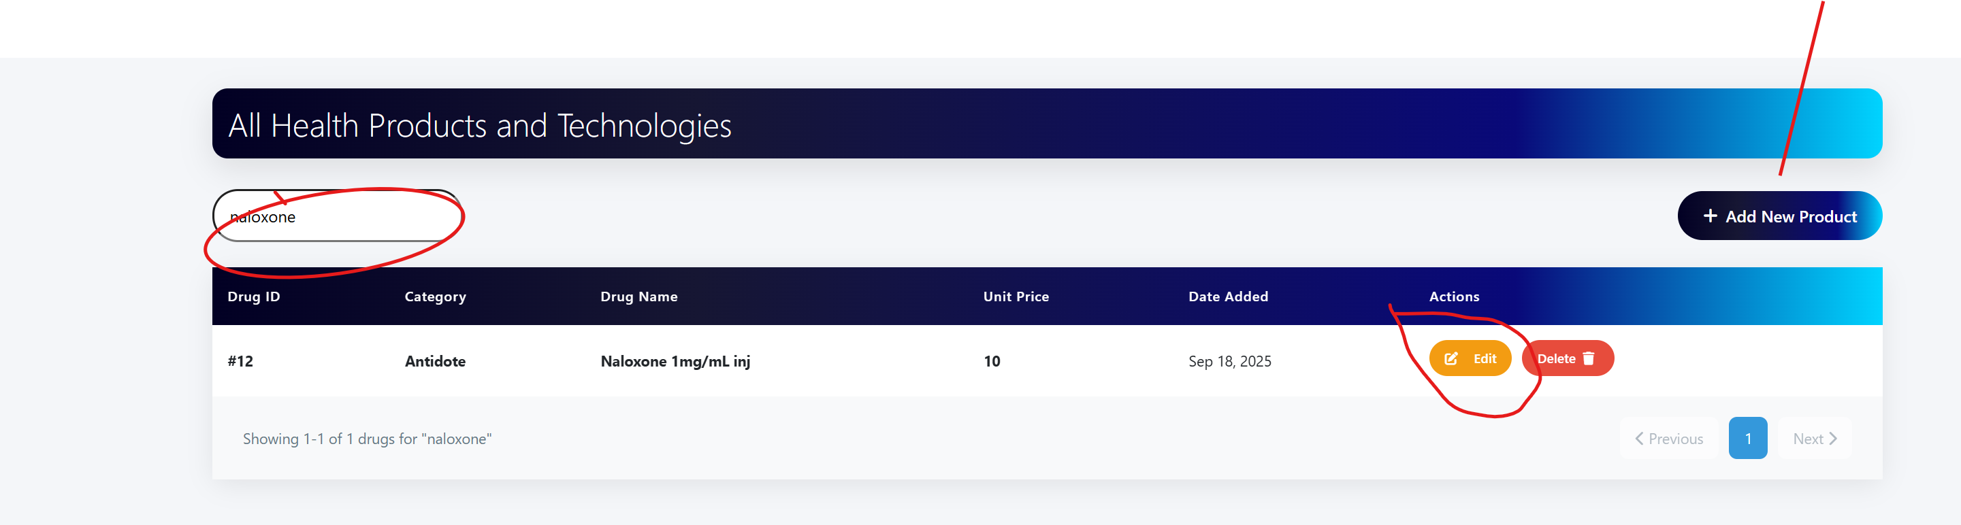

1. If it is not available, click “Add New Product” and repeat all steps in “Add items/drugs” above
2. If you want to change details, click Edit button Name, category, description and/or price

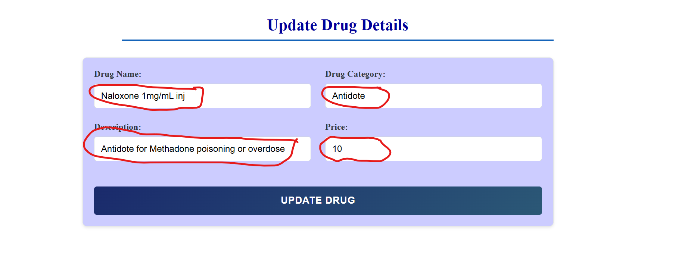

## View drugs dispensed

Click on “View dispensed drugs” to display dispensed drugs

Select the dates for which you want to view the dispensed drugs

Click on “Filter” button to view

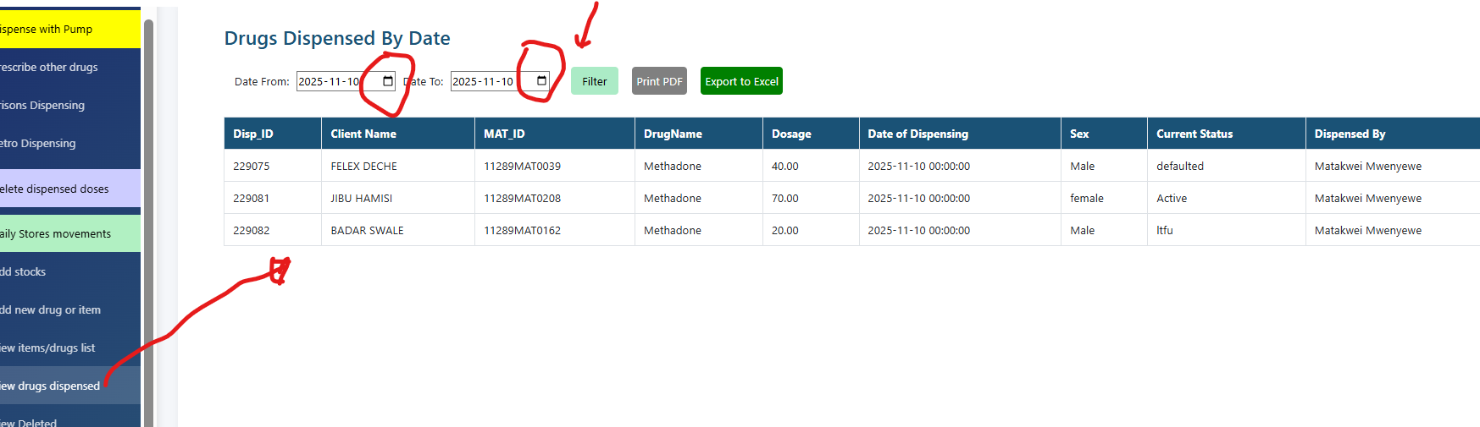

Click on the print PDF or export to down the excel file in the downloads folder.

Access the downloads folder by holding “CTRL + J”

Double click on the downloaded folder

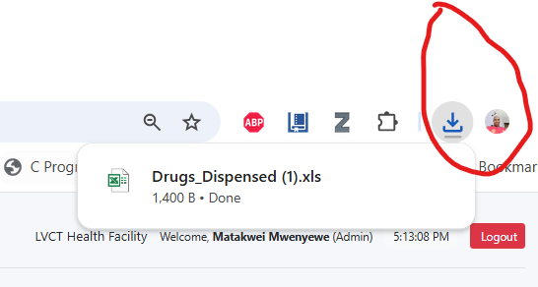

Click “Yes” to view the file

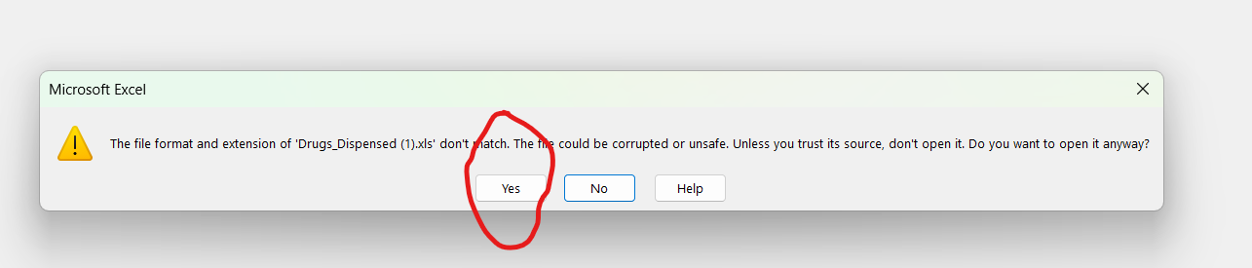

Save as “file_name_date

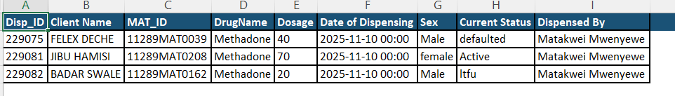

## View deleted prescriptions

1. Click on the “View deleted prescription” to view the deleted prescriptions

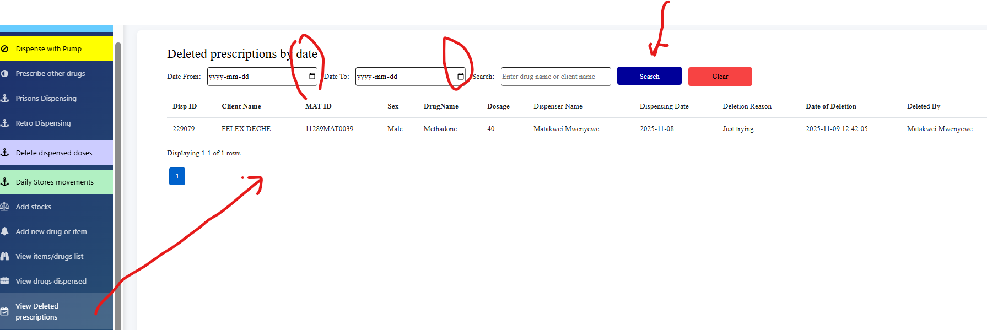

1. Select the start date and end date
2. This shows the reasons for deletion and the name of the deleting officer for audit purpose

## Stock taking

1. Click on “Stock taking” to open the window below

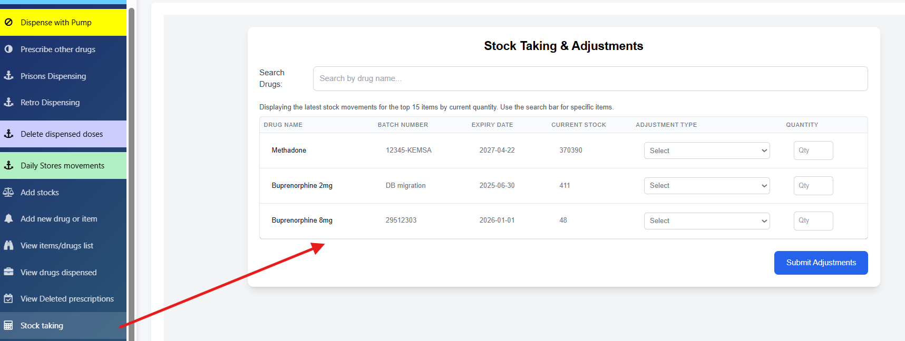

1. Select the reason for adjustment from the dropdown
2. Enter the quantity to be adjusted
3. Submit the adjustments and wait for success message
4. Check the current stock if the quantities have been adjusted
5. For a single item, search in the search bar and perform the operations

## Stock cards

1. Click “stock cards” to view a specific stock card transaction

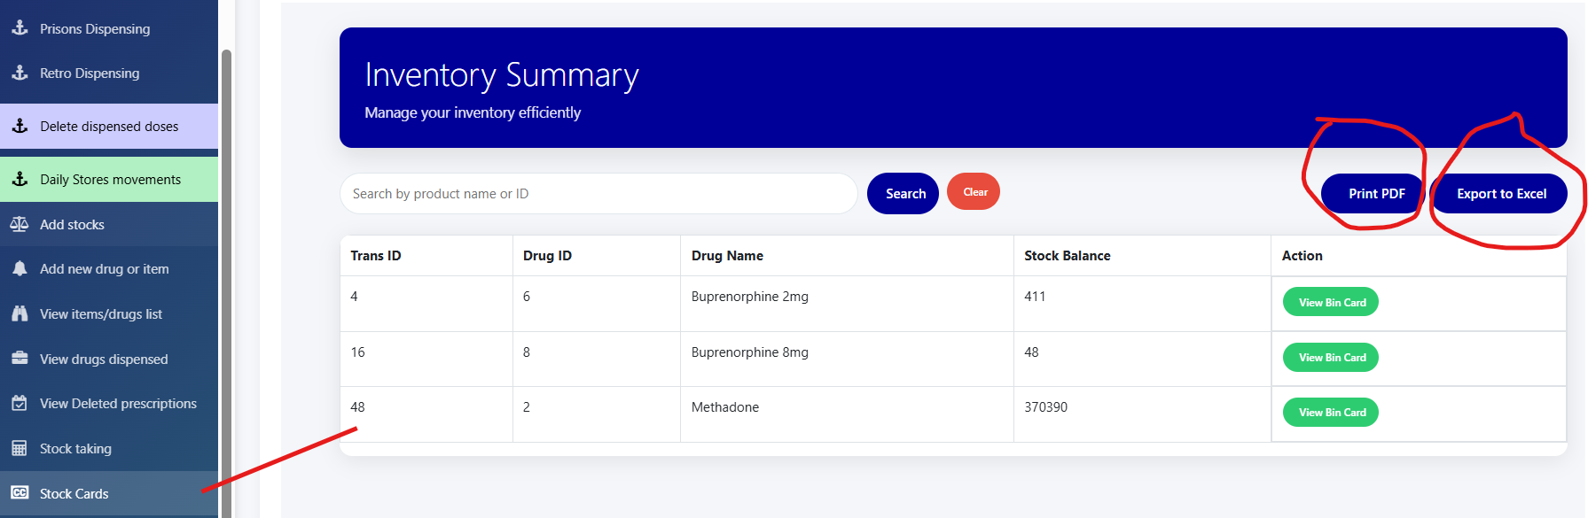

1. You can print PDF or export to excel and follow the steps like in “View drugs dispensed” procedure
2. For single item, input the name in search field which populates as you type or click “Search” button

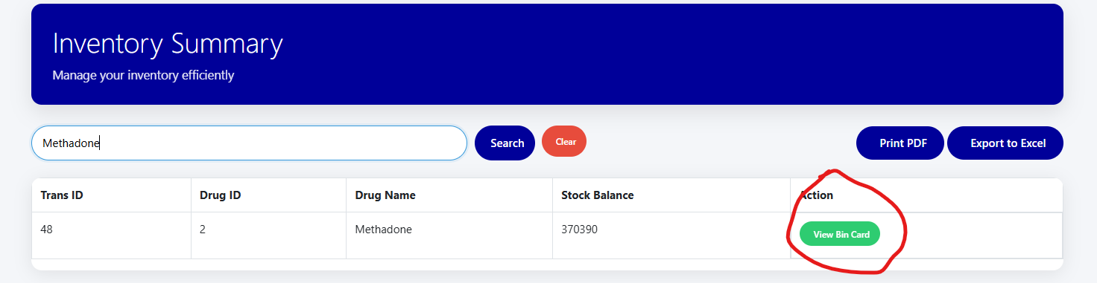

1. Click “View Bin Card” to see the transactions trail

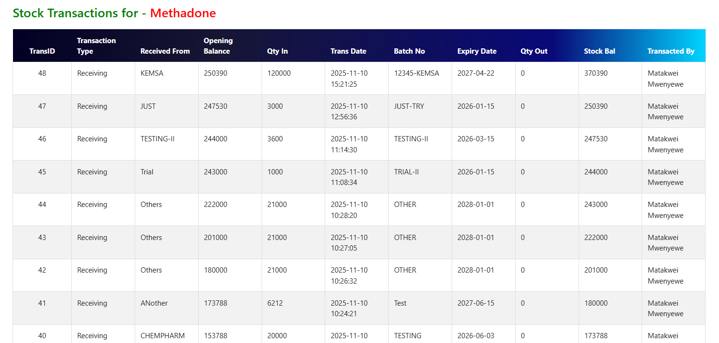

## View referrals

1. Refer to the Referrals module procedure

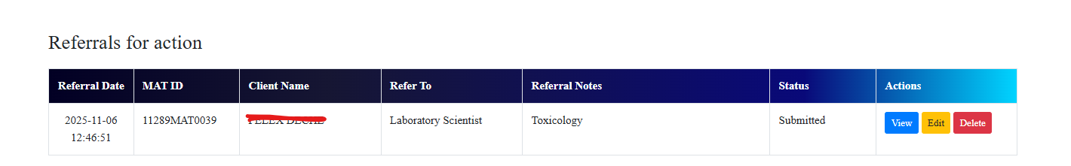

## View prescriptions

1. Click on view prescriptions to see any pending prescriptions

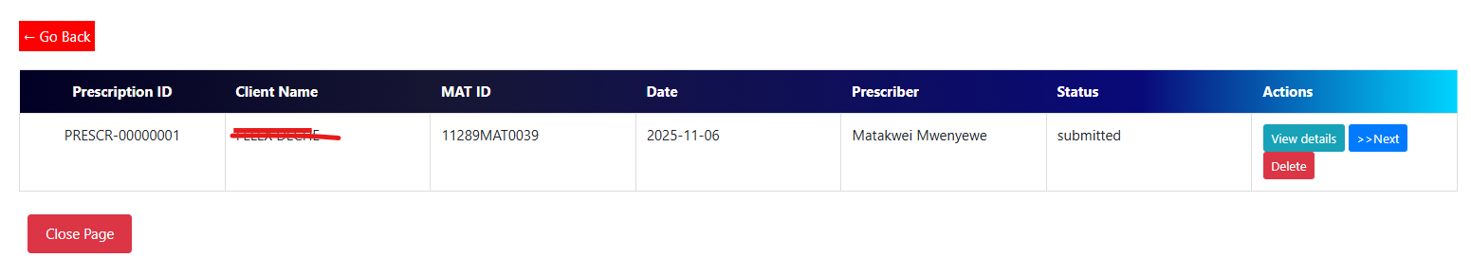

1. Click on “View details” to see the details of the prescriptions

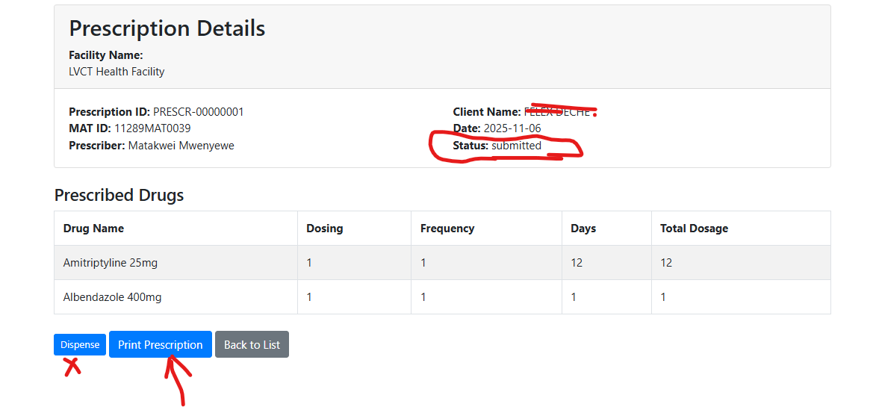

1. View status, if “submitted” – proceed to dispense by clicking “dispense” button if drugs are available in stock
2. Fill in the total quantities to dispense and press “Submit Dispense”

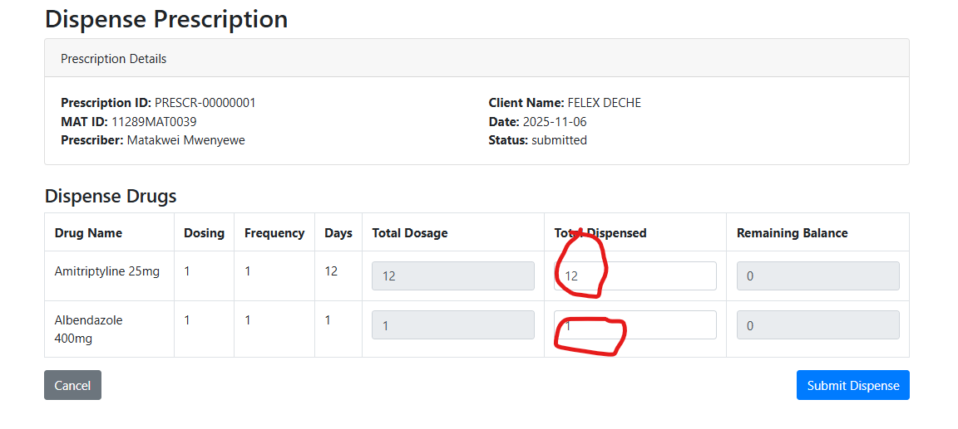

1. Once the dispensing process is complete, you will be redirected to view prescriptions that will be blank

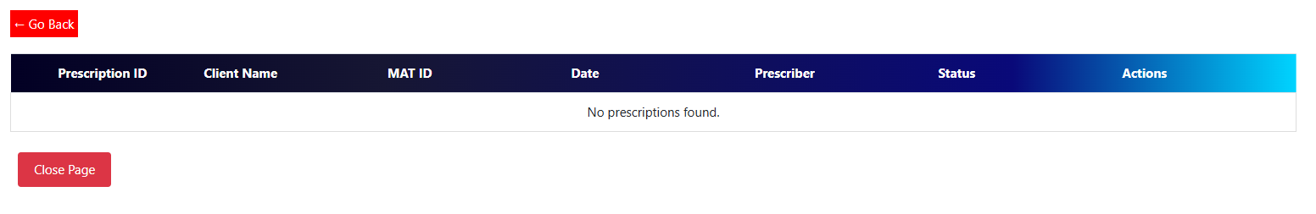

1. Close the page to exit the operations or proceed to view closed prescriptions

## View closed prescriptions

1. Click on “View closed prescriptions” to display completed prescriptions

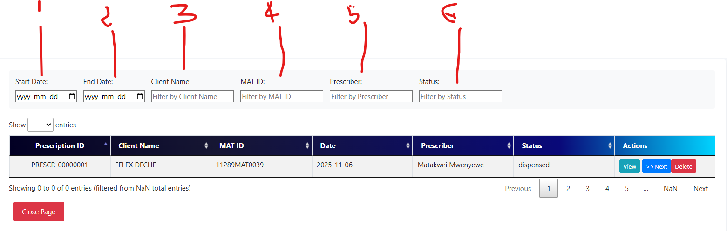

1. Search by
   1. start date and end date or
   2. Client Name or
   3. MAT ID or
   4. Prescriber Name or
   5. Status
2. Once the client’s prescription is retrieved, click on print prescription to print or delete if dispensed wrongly

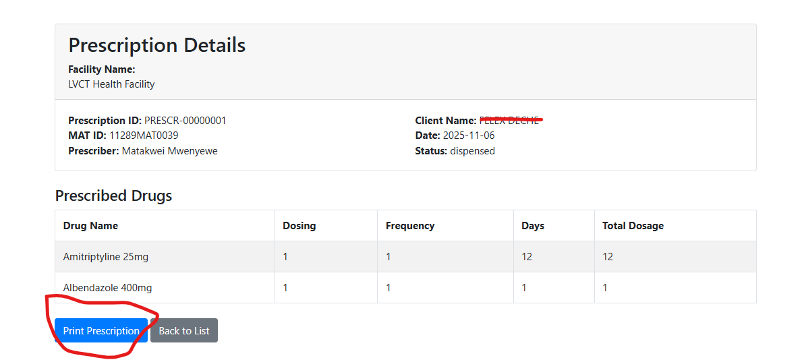

1. The view will display the following

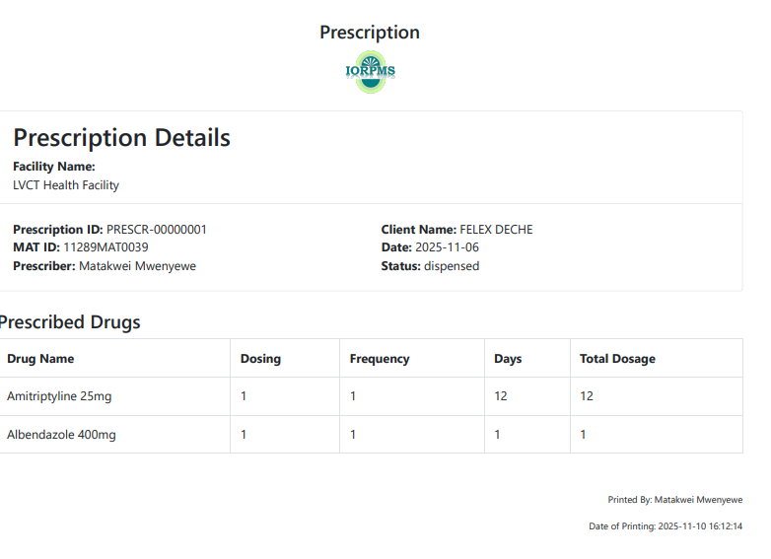

# CLINICIAN

Select Clinician Module from the dashboard

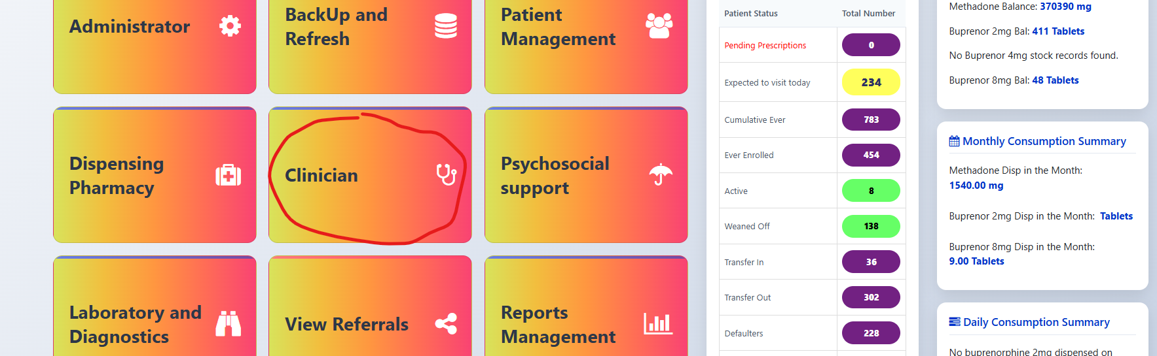

## Consent Form 2E

## Clinical initial encounter

## Update dosage

## Clinical follow up – OLD form

1. Click on Clinical Follow Up _OLD

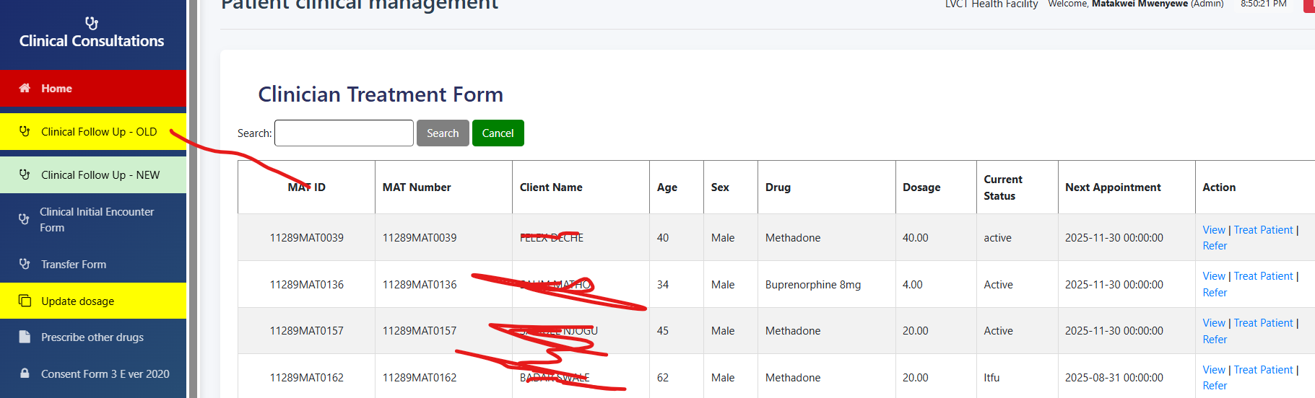

1. Search for the client using
   1. MAT Id or
   2. Client Name or Sex,
   3. Or Current Status or Age or Drug
   4. The search auto-populates automatically
2. Click on treat patient button to open the form below

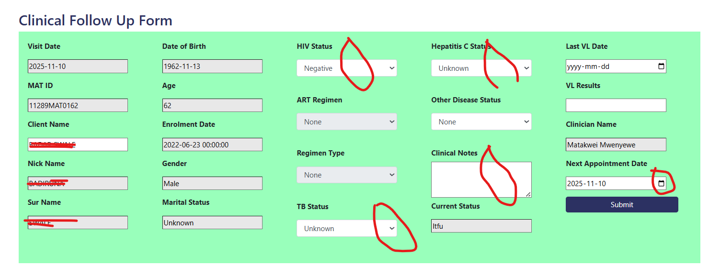

1. Fill in the non-hidden fields by selecting the options
2. Fill the clinical notes and give next appointment
3. If the HIV results are “Positive”, select the ART regimen and ART regimen type

## Clinical follow up – New Form

1. Click on the “Clinical follow-up new” to open the window below

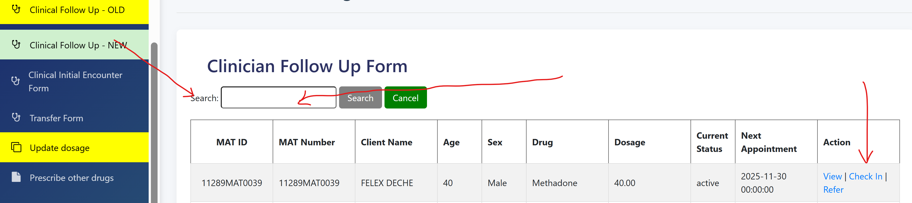

1. Search the clients’ name by MAT ID to display the patient details
2. Click check in to open the follow-up form below.

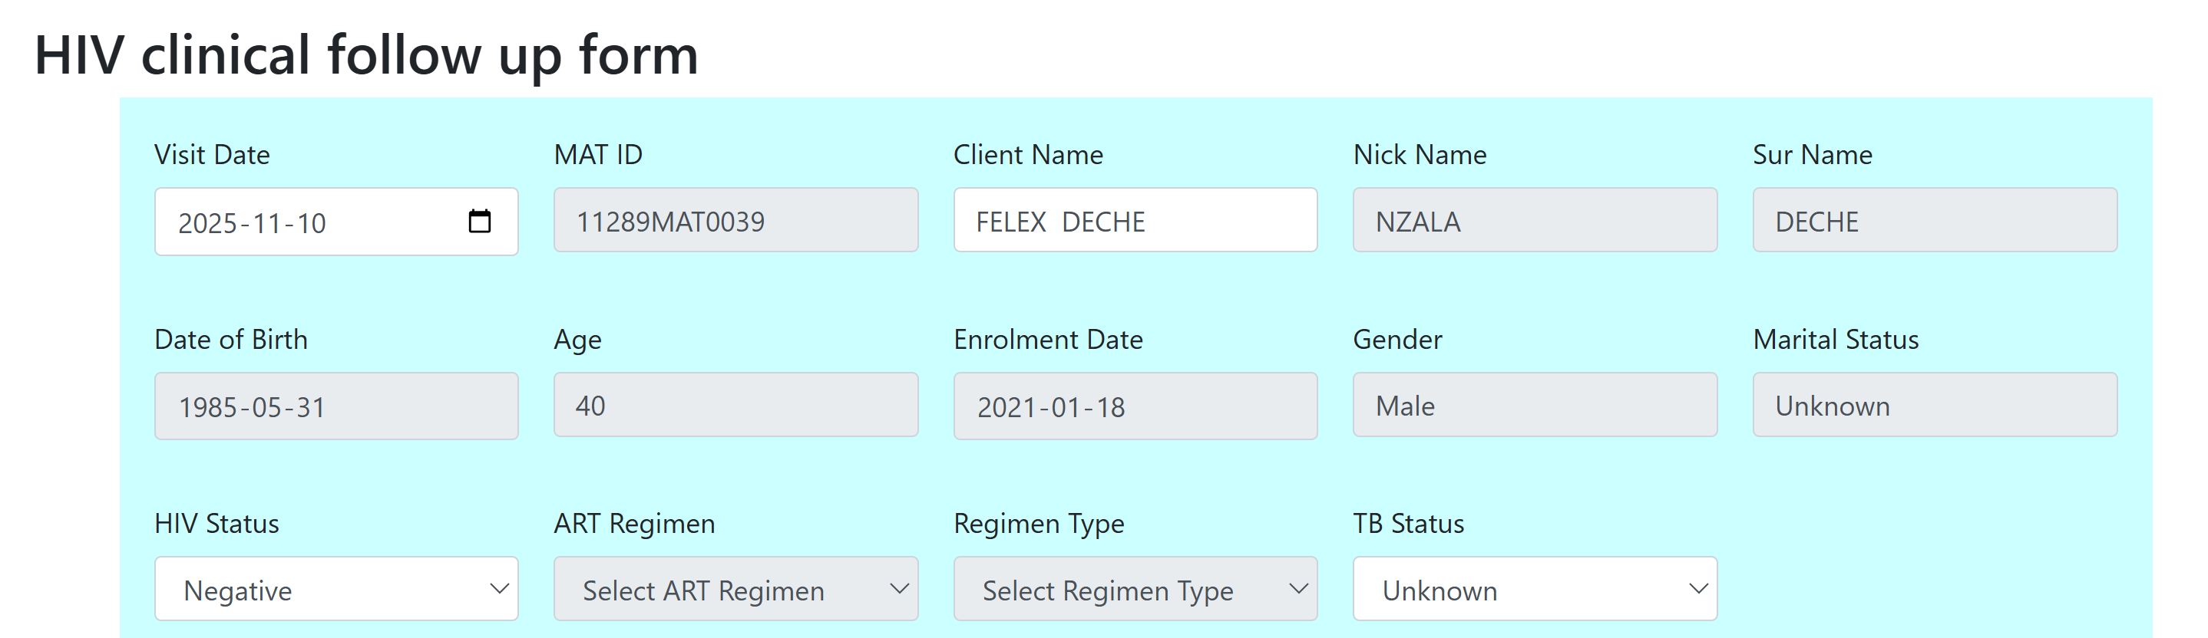

1. When the HIV status is Negative, the regimen and regimen type is hidden. Select “Positive” if the client is positive and choose the ART regimen and Regimen Type

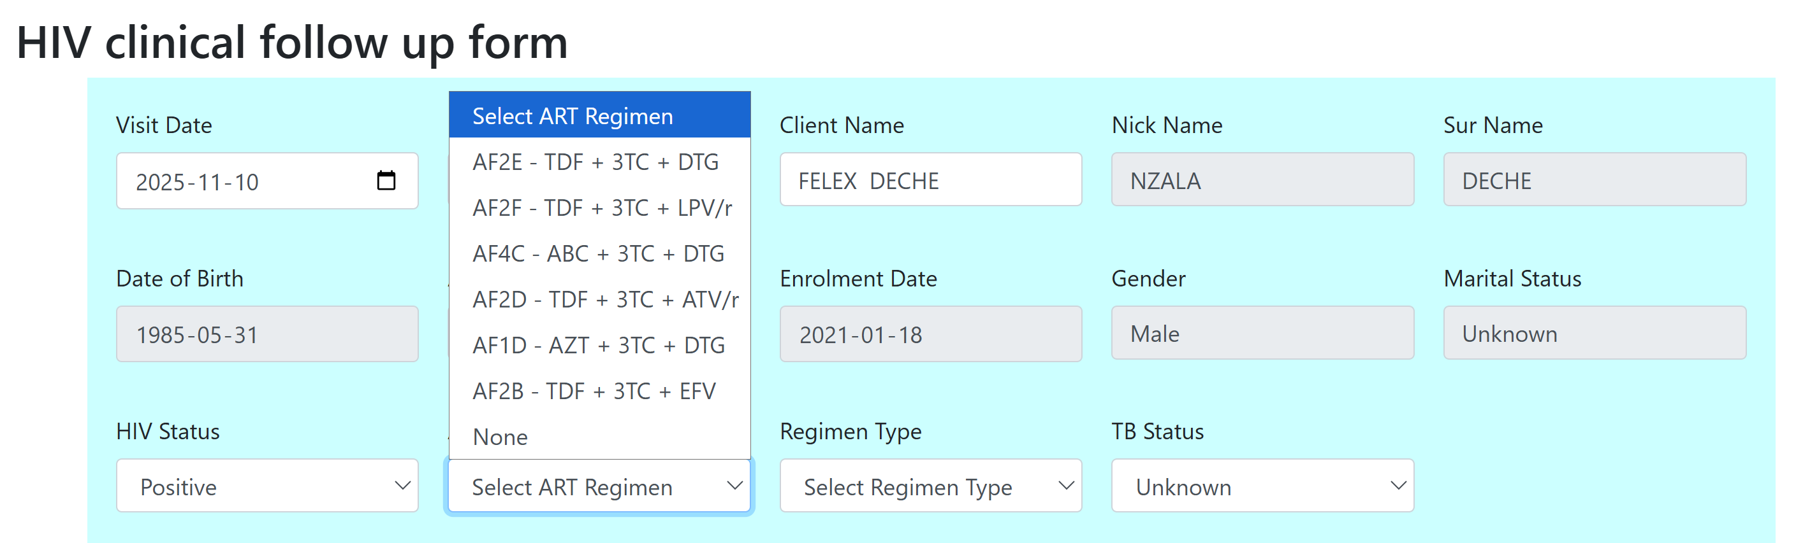

1. Select the TB status to display the TB regimens. Otherwise, the default is “Unknown” and the regimen is TPT. When it is positive, select the TB regimens, select the start date and end date

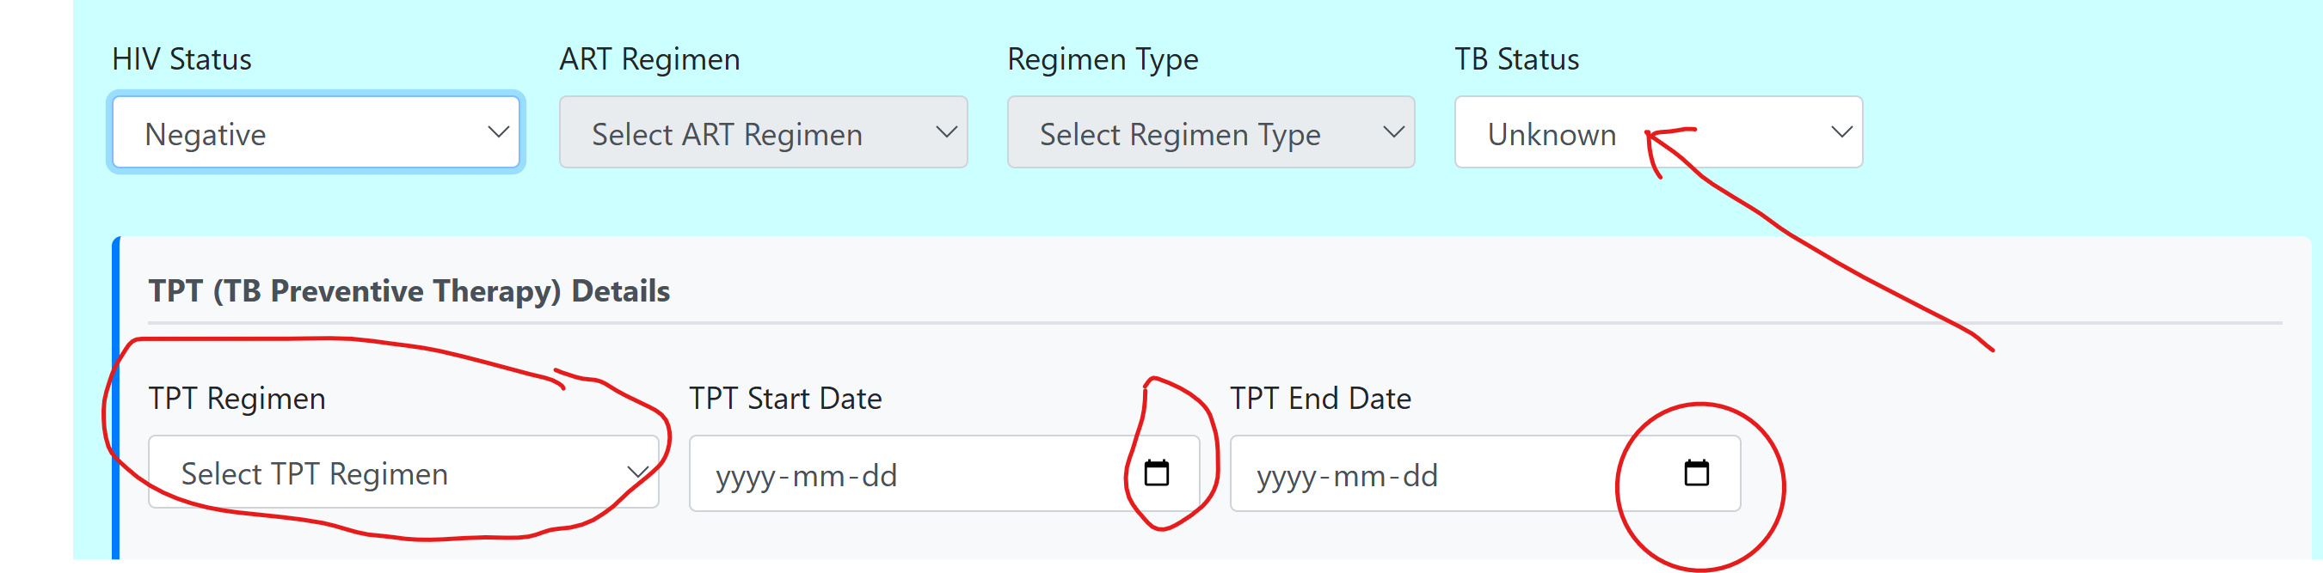

1. Select the remaining details

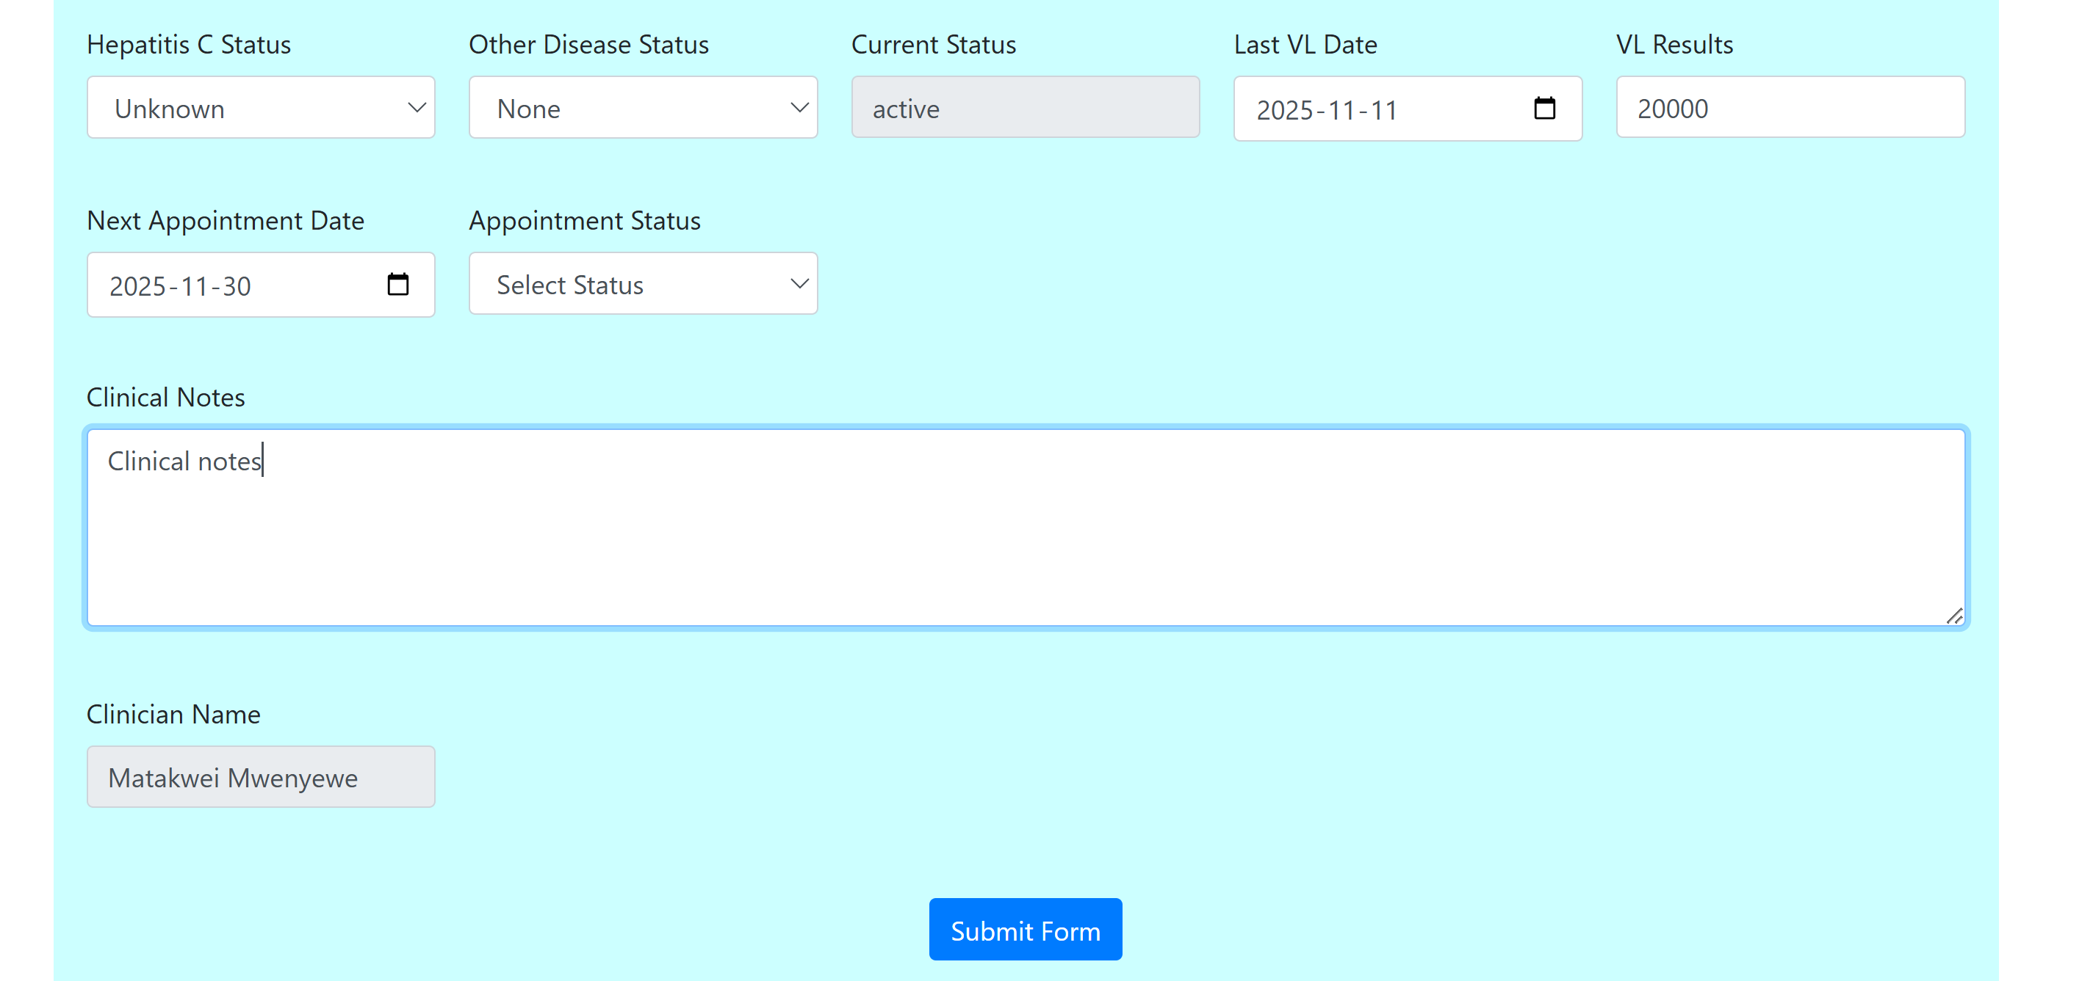

1. Make any clinical notes and submit the form

## Prescribe other drugs

## Involuntary discontinuation

## Voluntary discontinuation

## Transfer Form

# PSYCHOSOCIAL SUPPORT

1. Click on the Psychosocial support module to access

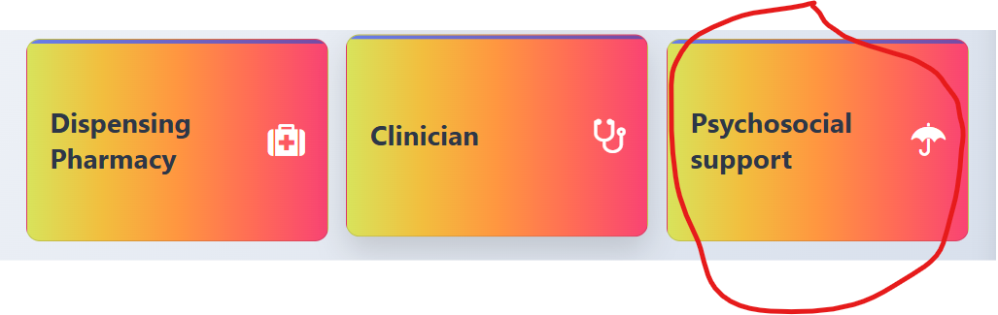

## Psychosocial intake form 2A

## Psychosocial intake form 1A

## PHQ-9 Form

## GAD-7 Form

## Community Screening Tool

## MAT cessation form 2E

## Psychosocial treatment Plan form 2B

## Psychiatric Encounter form 3J

## Psychiatric treatment plan

## Prescriber psychiatric drugs

# LABORATORY AND DIAGNOSIS

## Routine test

1. Click on perform a test and enter the MAT id or name to search

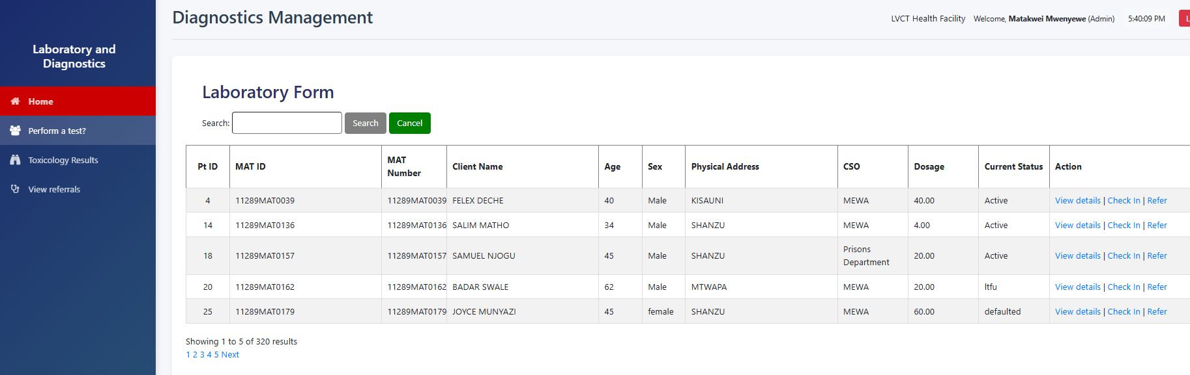

1. Click the ‘Check in’ tab to open the daily activity register

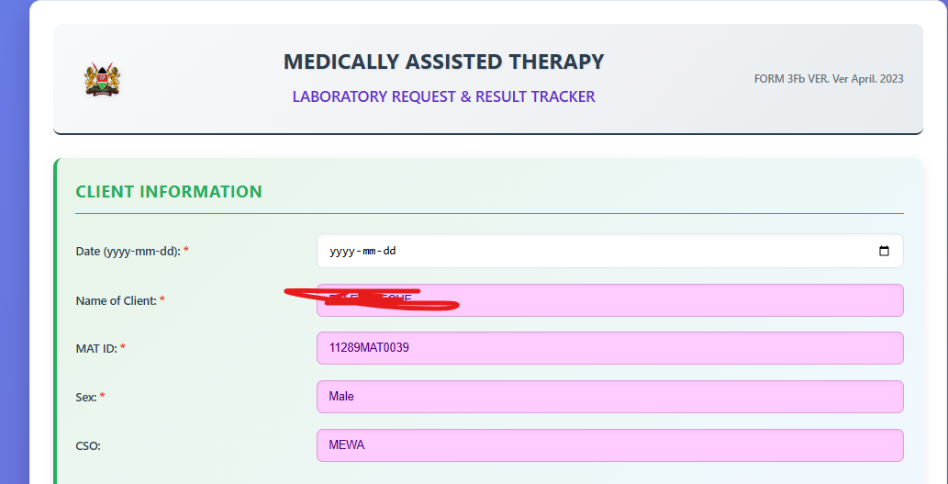

1. Select the date, visit type: New, or Routine or Re-induction of follow-up visit
2. Select the routine test results, either positive or negative or if not done – select “Not Done”

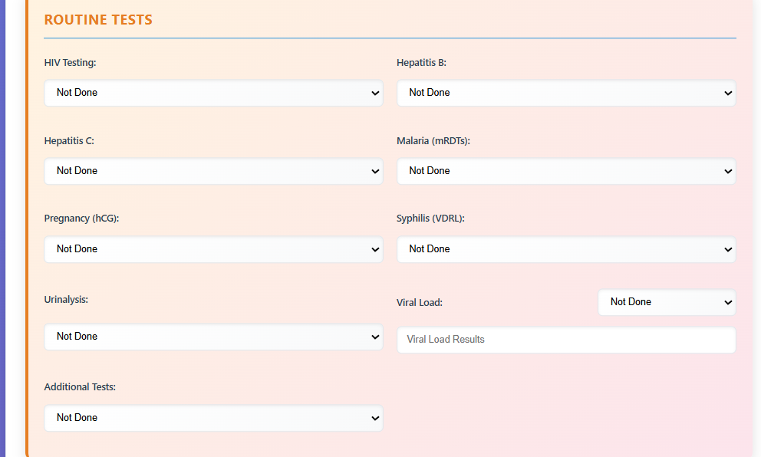

1. Select the toxicology results if done

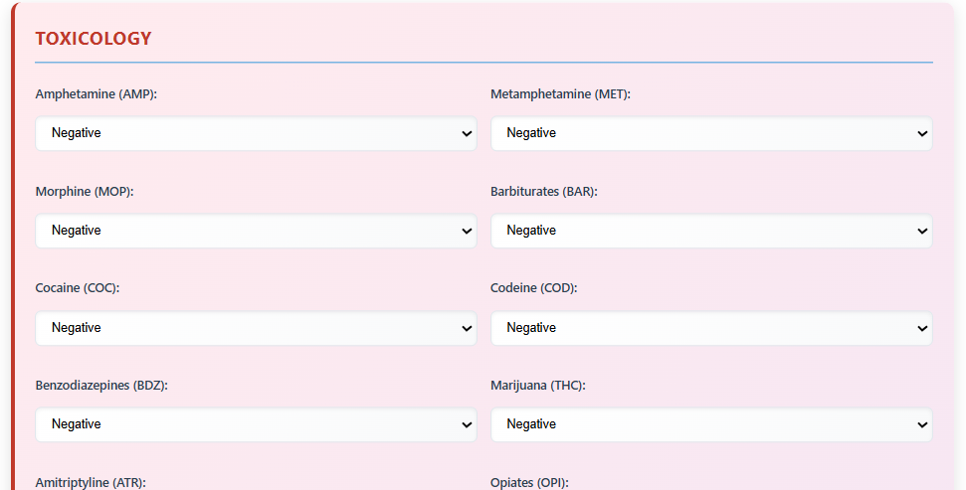

1. Make laboratory notes, input the date of test and next appointment and submit the results

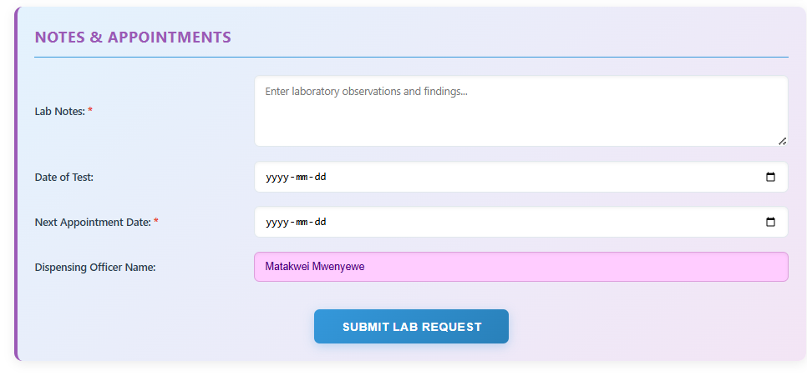

## Referrals

1. Click on Perform a test tab and select “refer” tab

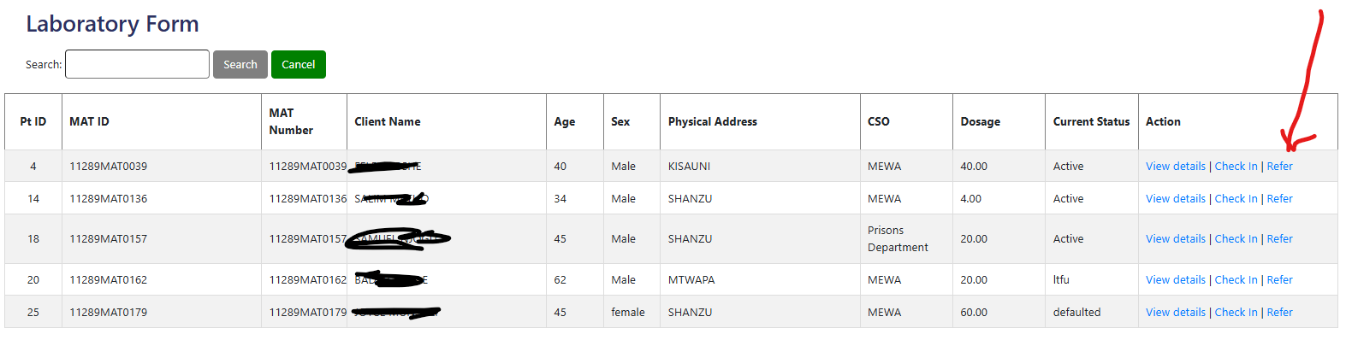

1. Select from the department where you want to make referral to and make some notes for the healthcare worker to review

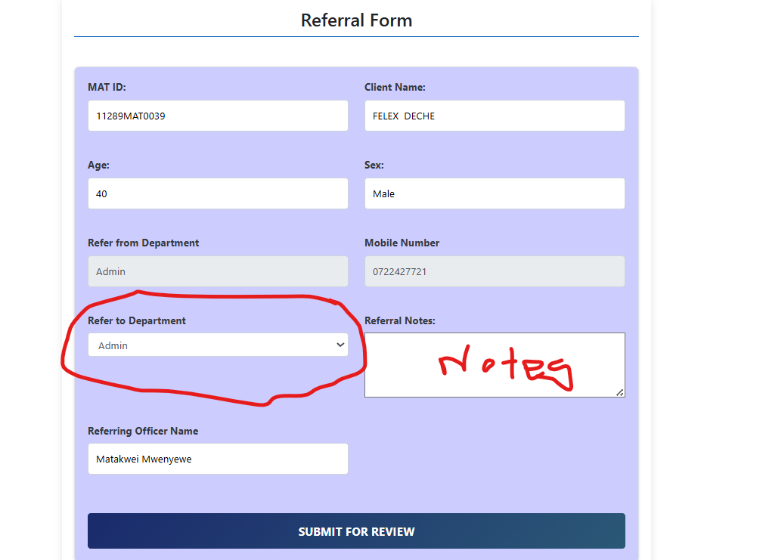

1. Click submit for the referral to go to the department



# VIEW REFERRALS

Open the referrals module from the dashboard

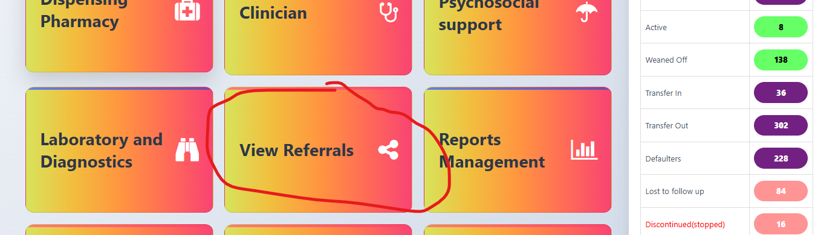

## Show completed referrals

1. Click on the “Completed referrals” as an Admin to view all referrals submitted and actioned on

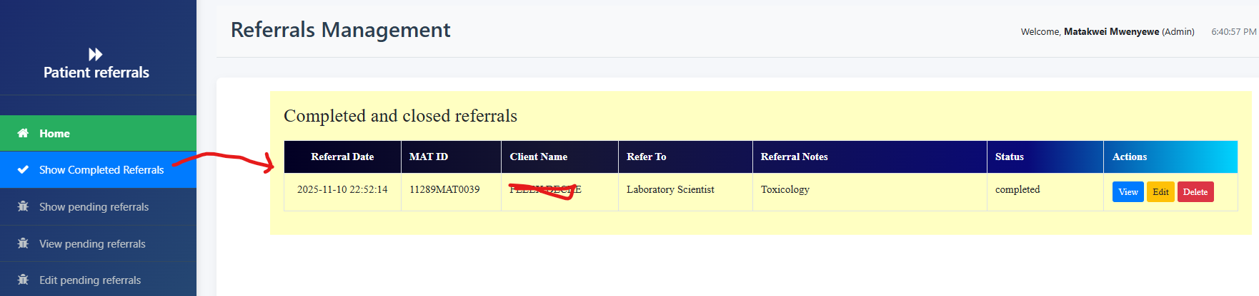

1. Click on the view button to display the referral details with **“COMPLETED”** status:

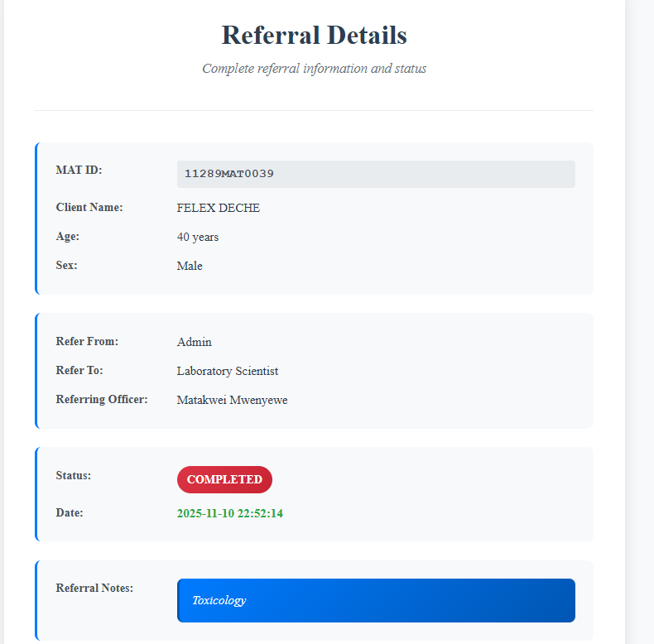

1. Delete referral deletes the existing referral

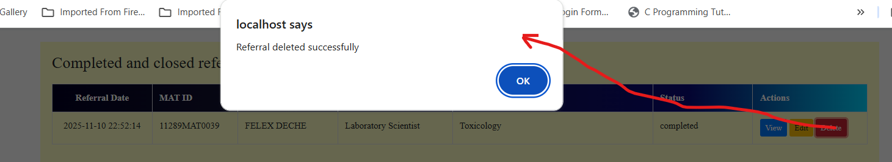

1. Click “OK” to confirm the deletion

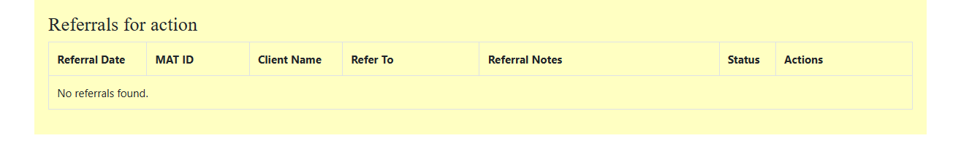

## Show pending referrals

1. Click on “show pending referrals” to display the window below

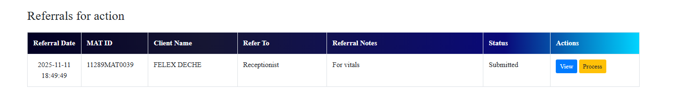

1. View button displays the referral details like the SOP above for completed referral but with **“SUBMITTED”** status

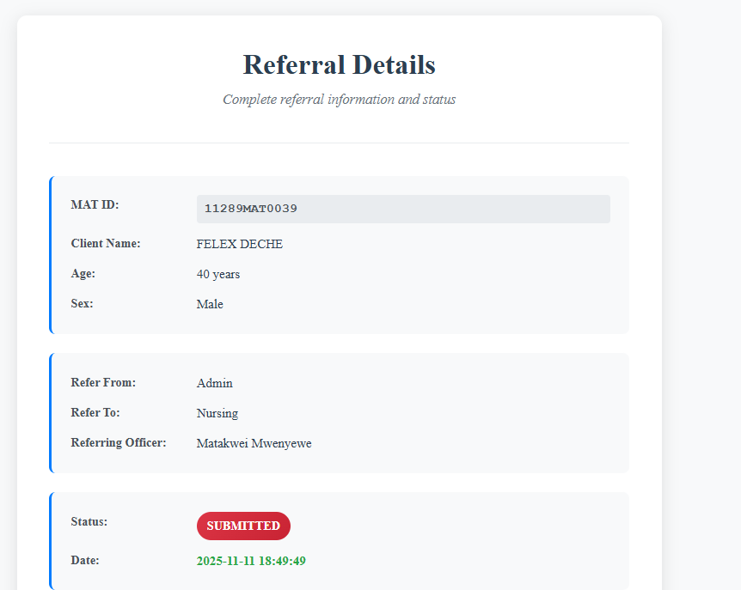

1. Process referral displays options to select reviewed and completed

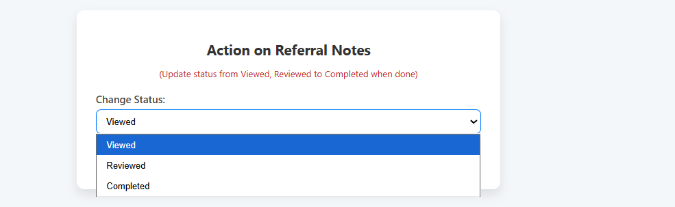

1. If you have seen the client but pending completion, mark as **“REVIEWED”**
2. When you have offered services to the client, mark as **“COMPLETED”**

## Redirect pending referrals

1. When the referral has been pending for some time, open the “Redirect pending referrals“

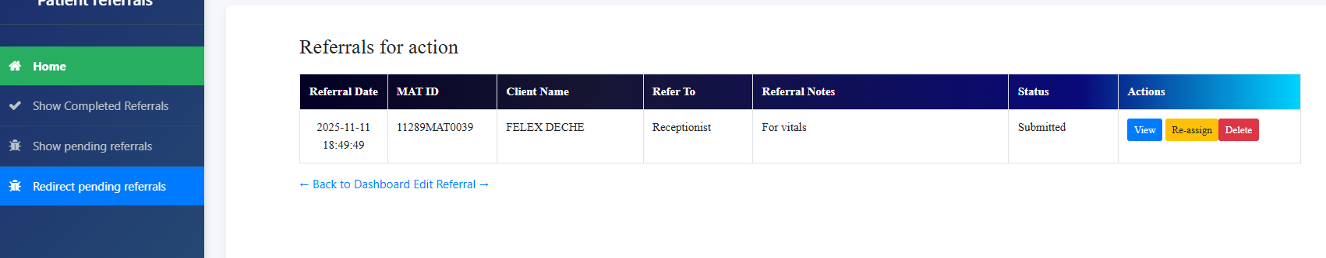

1. View – displays the referrals details included – “Referred-to”
2. Click on the “Re-assign” button to change the officer responsible

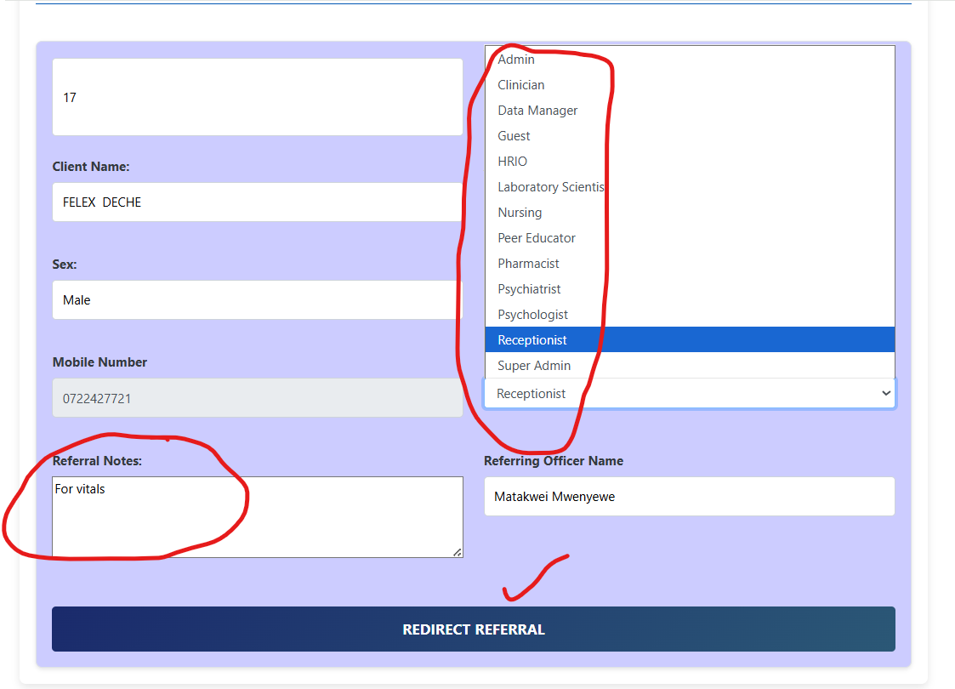

1. Change the Refer to Department by selecting another officer responsible from the dropdown
2. Maintain the referral notes or change and click Redirect Referral”
3. The referral will go to the redirected user

# REPORTS MANAGEMENT

## Daily clinic summary

1. Select the Reports Management module from the home landing page

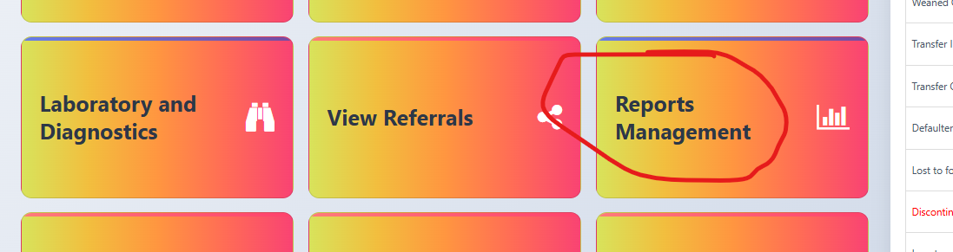

1. Navigate to each tab to view the details

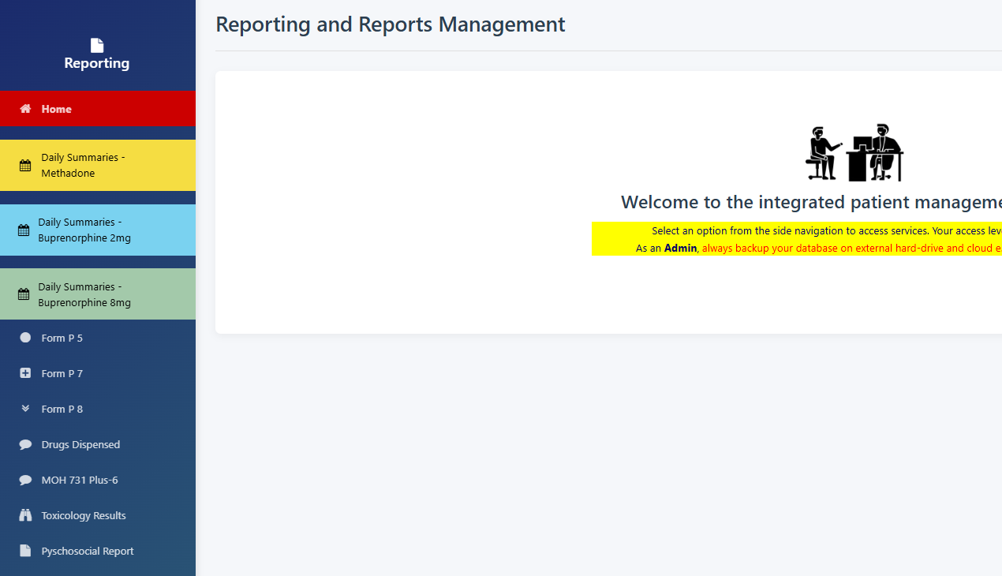

1. Select the Month though by default is the current month and click Update Report button to view summary for the month.
2. This display daily stocks movements from the controlled stores (STRONGROOM) to the dispensing area
3. The daily summaries are for: Buprenorphine 2mg, Buprenorphine 8mg and Methadone

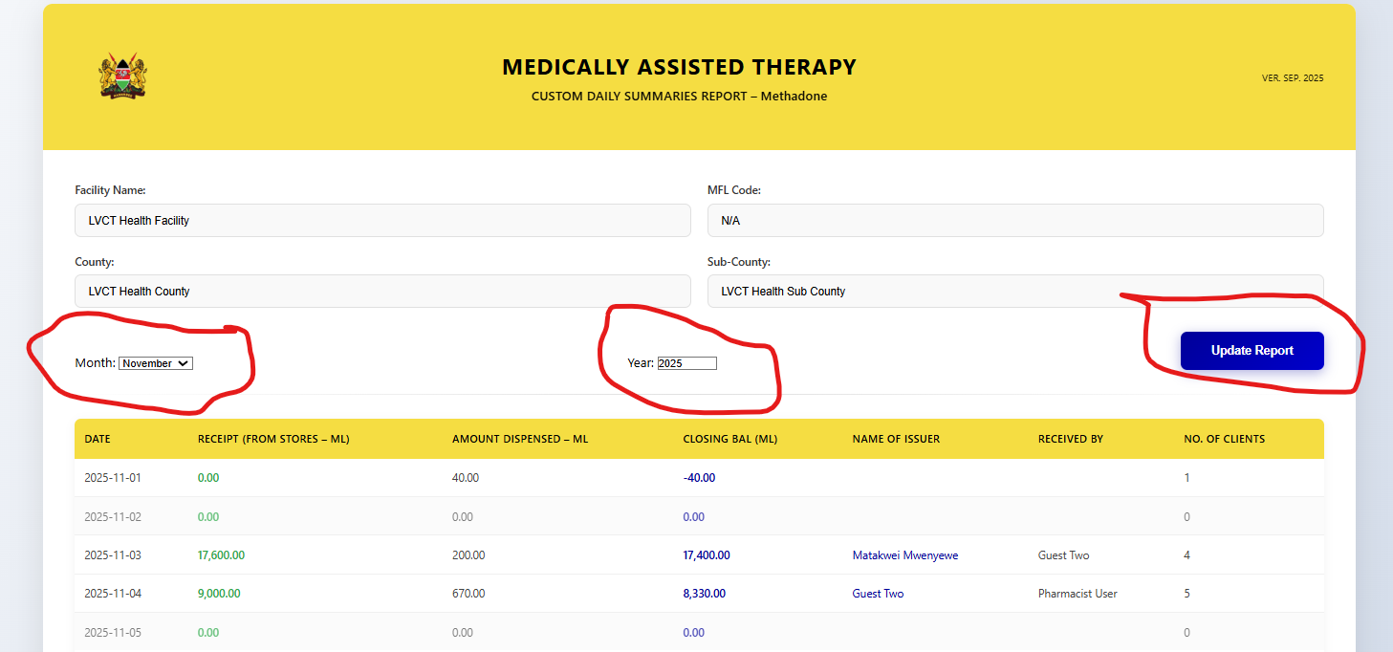

## P5 Form generation

1. For form P5 daily dispensing summary per patient:
2. Select Year from dropdown and Month from the Month dropdown and click submit button and wait for the report to run.

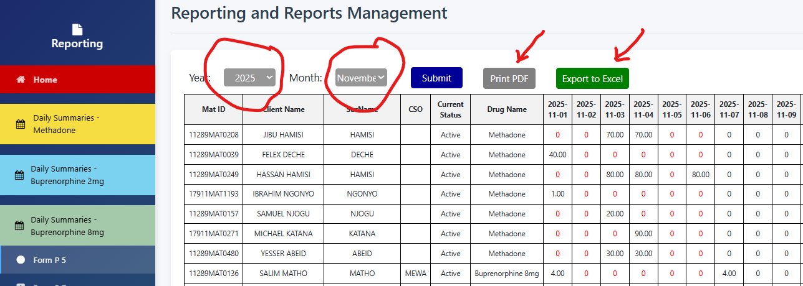

1. The output will take from 1 minute to 10minutes depending on the if it is run for the first time or subsequent refresh and also the number of clients.

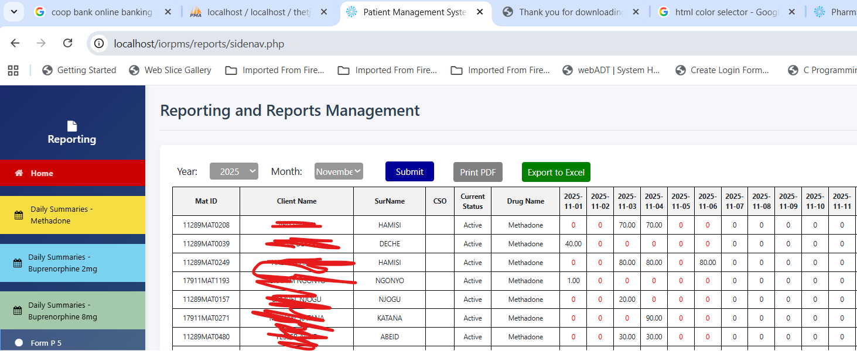

1. Check the url when the report is running until it stops

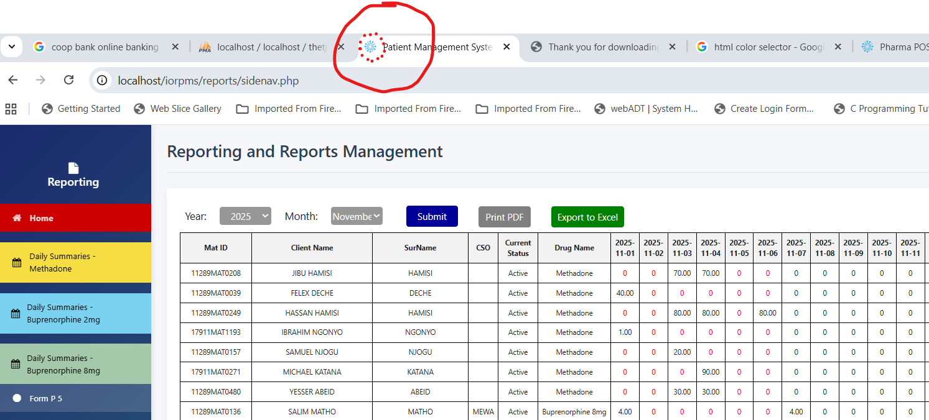

## P7 form generation

1. For from P7 when you select the Form P7 form it displays by default the report of the previous month. Example when the current month is November, the form will display report for October

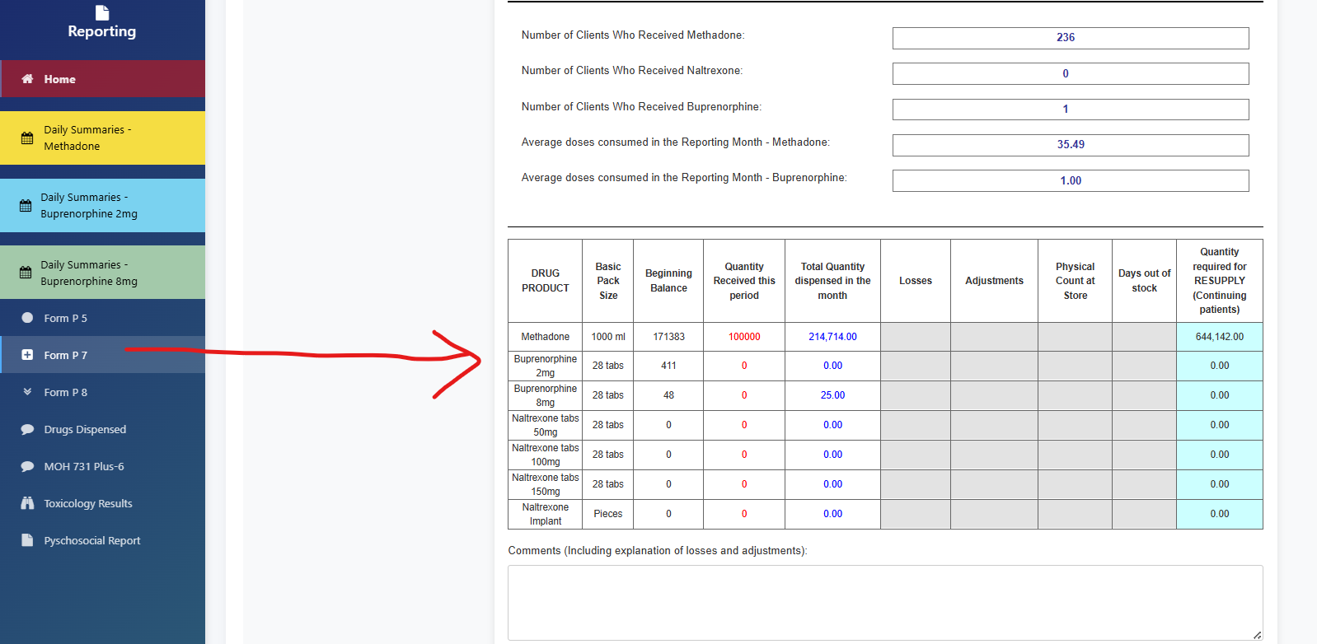

1. To select the specific month report, select the start date and end date from the display form and click ‘Update dates’

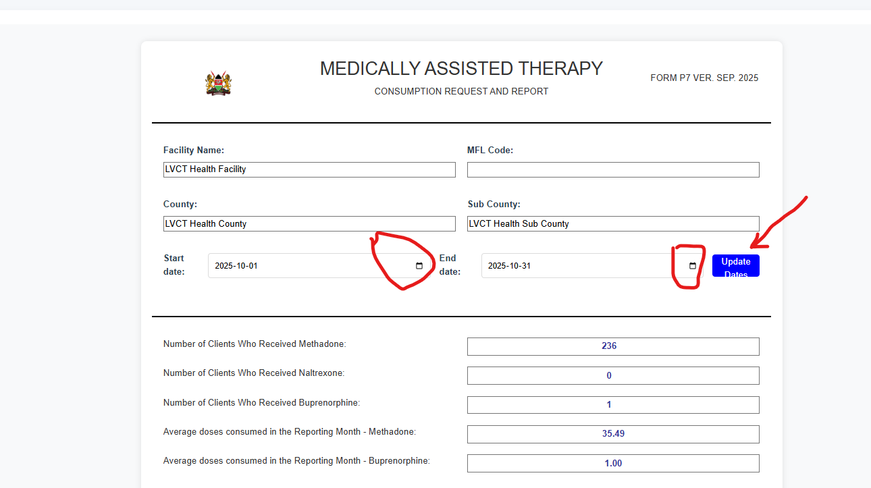

1. Fill in the details in the form below (mobile phone and date of submission) and click print. The form will be saved and can be emailed to MAT in charge or Sub County Pharmacist

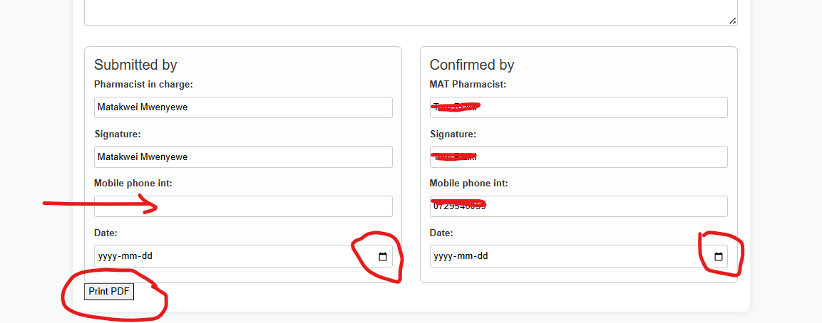



## P8 Form generation

1. For from P8 when you select the Form P8 form it displays by default the report of the previous month. Example when the current month is November, the form will display report for October

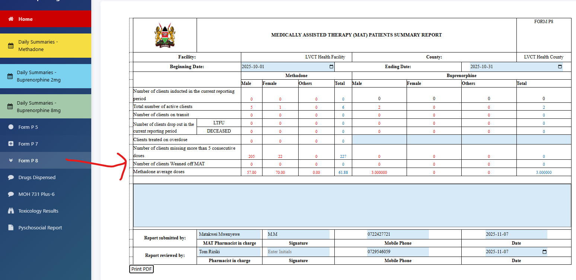

## Form MOH 731-6 Plus

1. Click on the MOH 731-6 plus
2. Select the start date and end date from the calendar dropdown
3. To select the specific month report, select the start date and end date from the display form and click ‘Update dates’

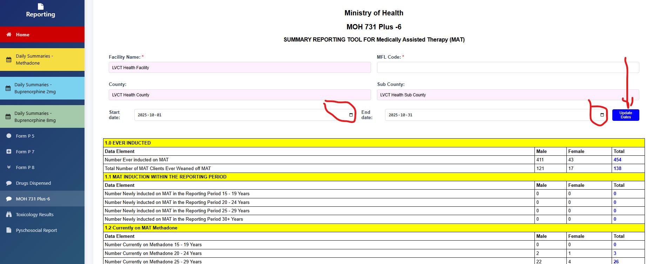

1. For from MoH 731-6 Plus, when you select the MoH 731-6 Plus form it displays by default the report of the previous month. Example when the current month is November, the form will display report for October
2. Print as PDF and email to the in charge or save in a folder

## Toxicology Results

1. For from toxicology results, when you select the toxicology tab it displays a list of clients who have had toxicology tests done

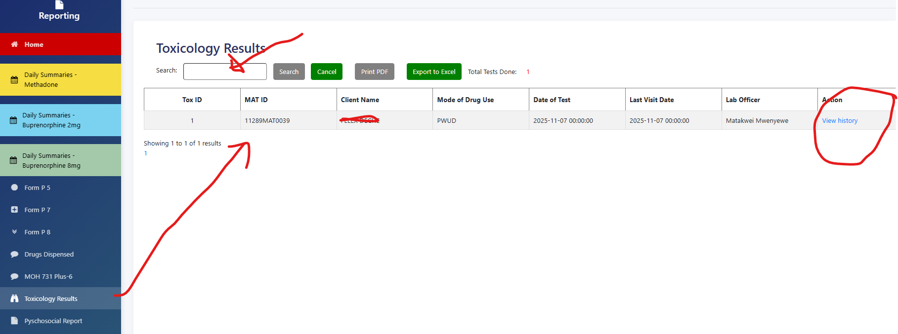

1. Search using client name or MAT Id and click view to see the details of clients toxicology history

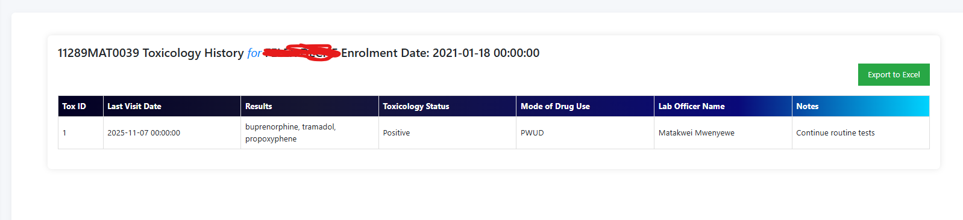

## Psychosocial Form

1. For from Psychosocial form, when you select the Psychosocial report it displays by default the report of the previous month. Example when the current month is November, the form will display report for October
2. To select the specific month report, select the start date and end date from the display form and click ‘Update dates’

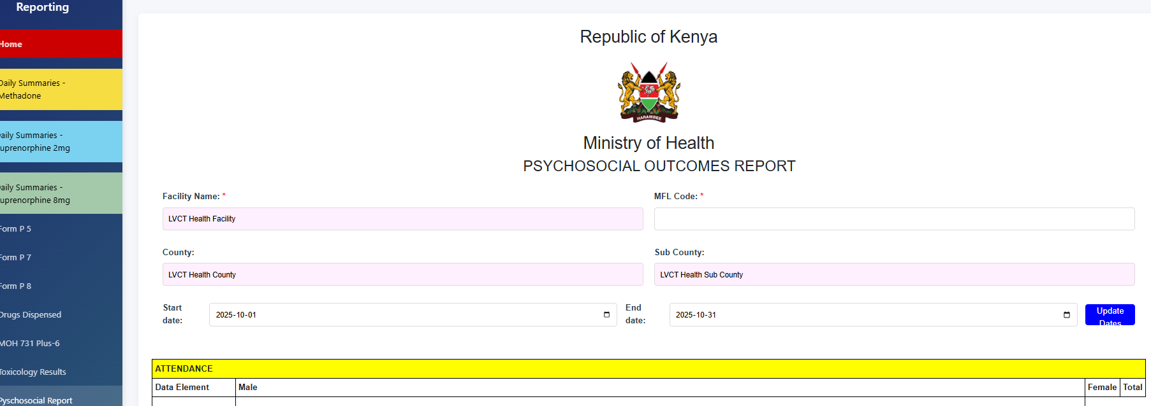

1. Click home tab to go back to the main dashboard

# BIOMETRICS

## Capture photo

1. Click on the biometrics module to open the search page and enter the name or MAT ID

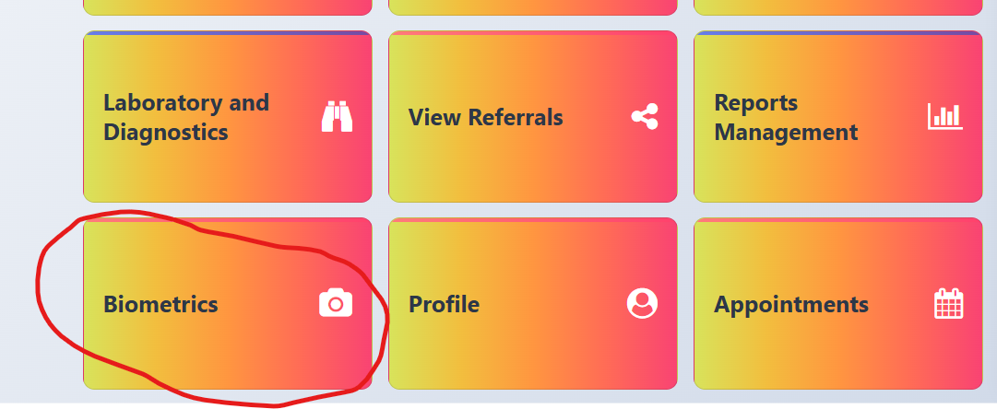

1. If the photo status shows ‘no photo’ click on capture photo

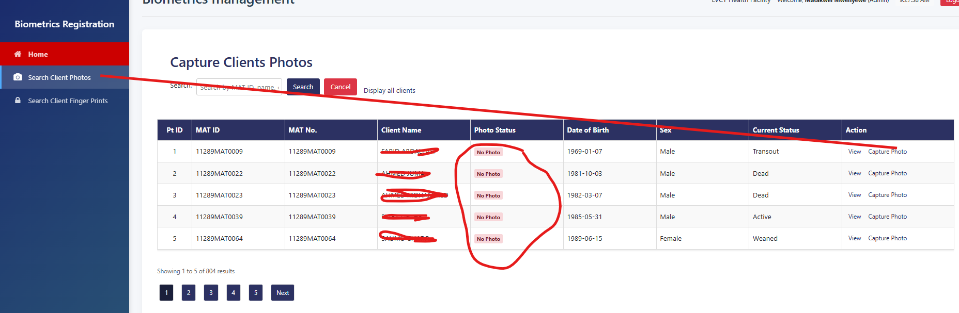

1. Capture photo and save

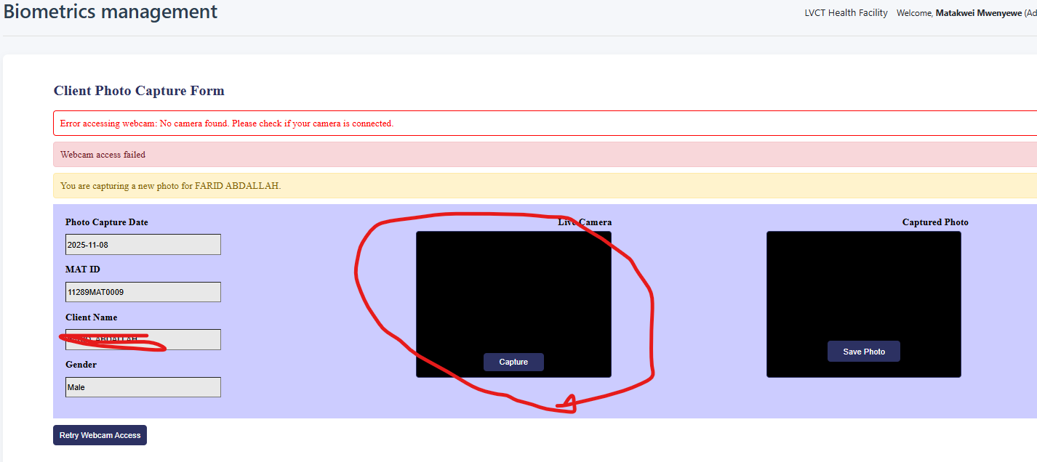

## Fingerprint capture

1. For finger print, search for the name or MAT ID and if ‘Not registered’ click register fingerprint

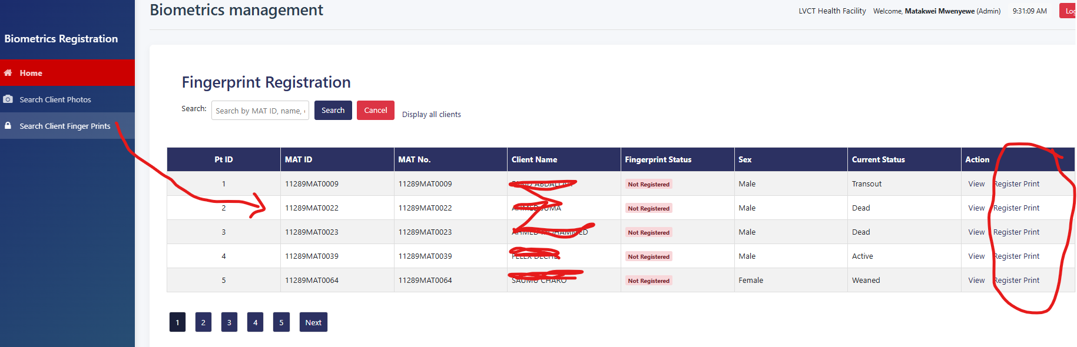

1. The client places the finger on the scanner then click “Start Capture” when the fingerprint displays, click save fingerprint

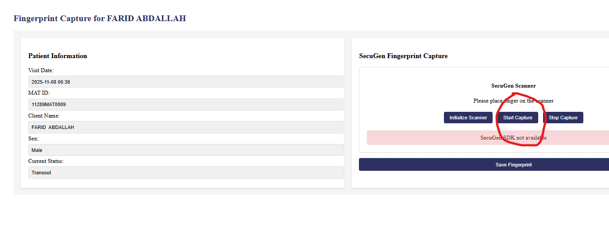

# PROFILE

## View profile

1. Click on ‘Profile module’ on the dashboard

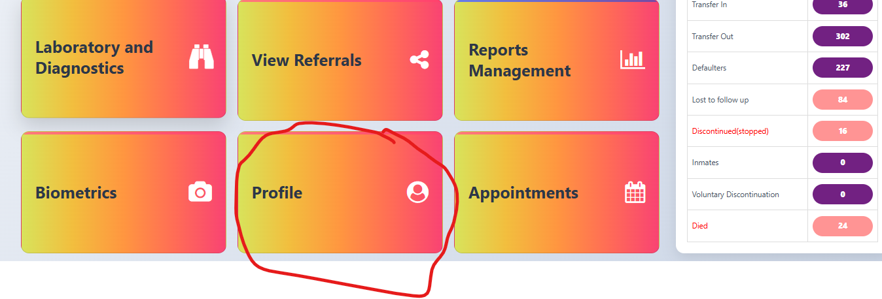

1. Click ‘View profile’

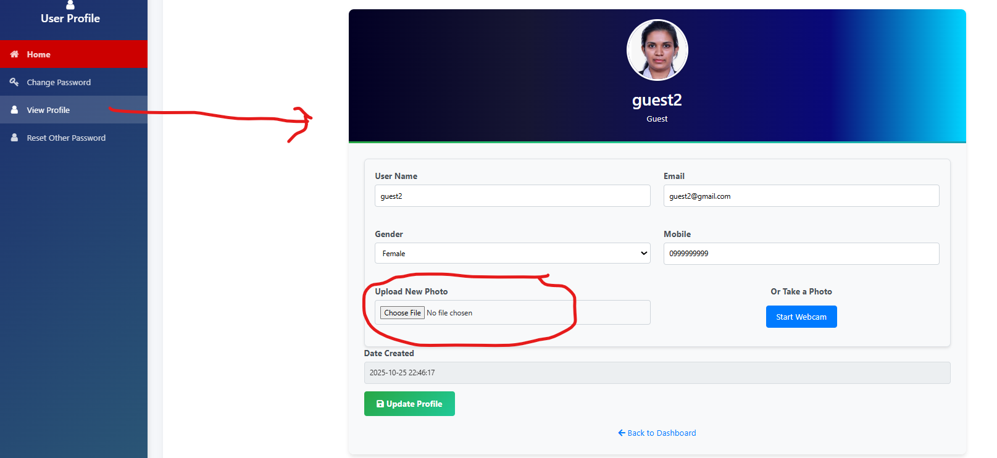

1. If your profile has no photo and you have it in a folder, click ‘Upload new photo’ and once done click “Update profile’
2. Only Admin can update the users’ role

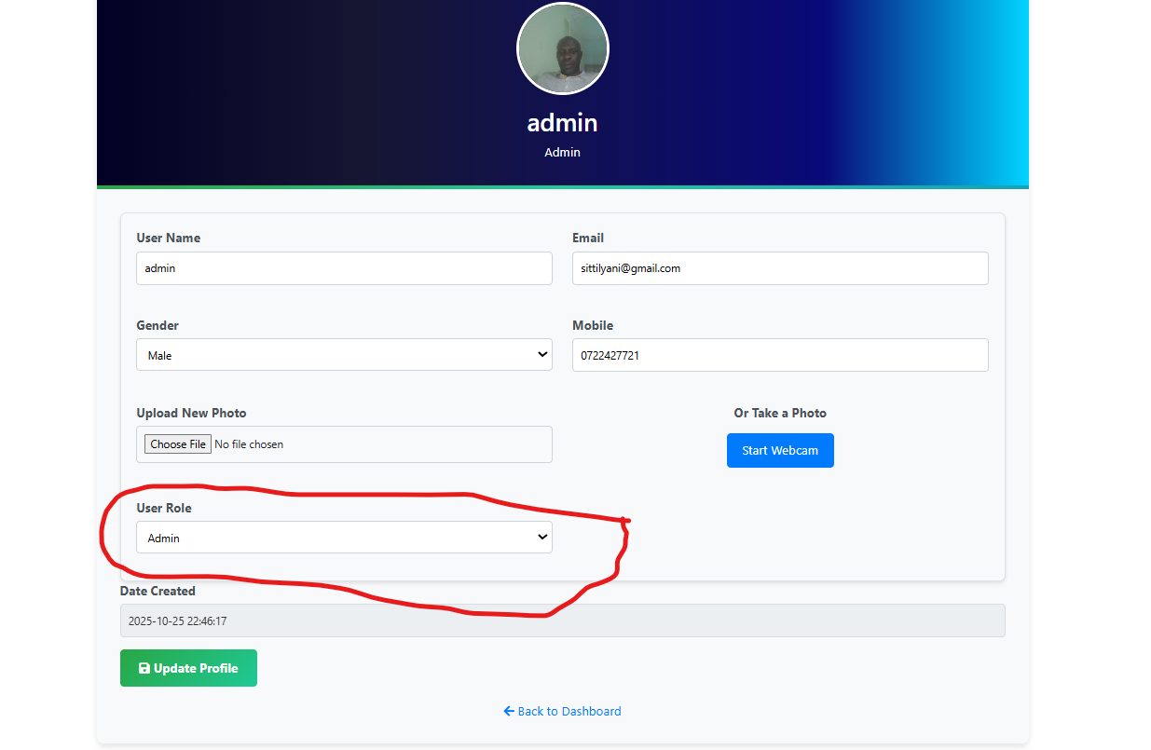

## Change own password

1. Click on ‘Change password’

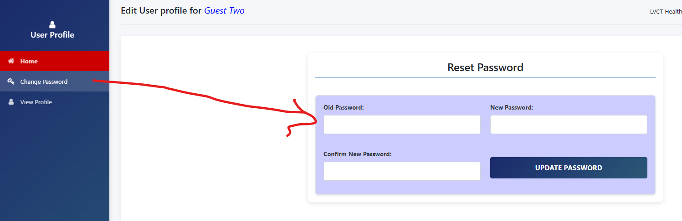

1. Enter the old password
2. Enter the new password and enter the same password in the confirm new password input and click “Update password’ wait for success message at the top of the page and click OK

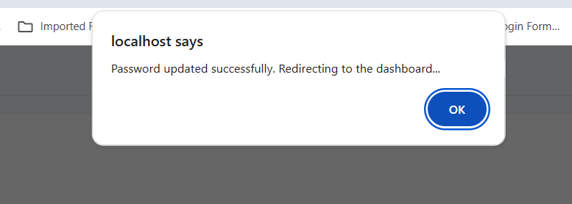

1. Click home button to continue with other operations

PUMP CONTROL

**PUMP CONTROL API MANUAL**

Pump Control Executable (pump_control.exe)

**Overview**

pump_control.exe is a command-line executable used to control a **Masterflex - compatible peristaltic pump** via a serial (COM) port. It is intended for use in **production environments**, including integration with PHP, JavaScript, or other systems that can execute EXE files.

The executable communicates with the pump over RS‑232/USB serial communication and returns **JSON-formatted responses** for easy integration.

**Key Features**

* Dispense a specified liquid volume
* Support for different tubing sizes (L/S14, L/S8)
* Speed scaling (percentage-based)
* Direction control (forward / reverse)
* Calibration system stored in JSON
* Raw command passthrough
* Emergency stop command
* JSON output (success/error)

**System Requirements**

* Windows 10 or later
* Available COM port (USB-to-Serial or RS‑232)
* Pump drivers properly installed

**Files Included**

* pump_control.exe – Main executable
* calibration.json – Auto-created calibration file (same folder)

⚠️ **Do not delete** the calibration file once created.

**General Command Syntax**

pump_control.exe <COM_PORT> <BAUD_RATE> <action> [parameters]

**Actions & Usage**

**1. DISPENSE**

Dispenses a specified volume of liquid.

**Syntax**

pump_control.exe COM13 9600 dispense <volume_ml> <tubing> <direction> [speed_percent]

**Parameters**

|  |  |
| --- | --- |
| **Parameter** | **Description** |
| volume_ml | Volume in milliliters |
| tubing | L/S14 or L/S8 |
| direction | f = forward, r = reverse |
| speed_percent | Optional (default = 100) |

**Example**

pump_control.exe COM11 9600 dispense 25 L/S14 f 150

**2. CALIBRATE**

Stores an accurate calibration factor for a tubing type.

**When to use**

* After tubing change
* For high-precision dispensing

**Syntax**

pump_control.exe COM13 9600 calibrate <tubing> <measured_ml> <steps_used>

**Example**

pump_control.exe COM13 9600 calibrate L/S14 9.85 12000

This creates/updates:

{ "L/S14": 0.0008208333 }

**3. RAW COMMAND**

Sends a raw command directly to the pump.

**Syntax**

pump_control.exe COM13 9600 raw "/1V1200L500R"

Use with caution ⚠️

**4. STOP (EMERGENCY HALT)**

Immediately stops pump movement.

**Syntax**

pump_control.exe COM13 9600 stop

**Output Format (JSON)**

All responses are returned as JSON.

**Success Example**

{

"success": true,

"response": "OK",

"steps": 12000,

"tubing": "L/S14"

}

**Error Example**

{

"success": false,

"error": "Access denied to COM port"

}

**Tubing Presets**

|  |  |  |
| --- | --- | --- |
| Tubing | Default Speed (V) | Load (L) |
| L/S14 | 1200 | 500 |
| L/S8 | 1800 | 900 |

Speed scaling is applied using the optional percentage argument.

**Integration Examples**

**PHP**

$cmd = "pump_control.exe COM13 9600 dispense 10 L/S14 f 120";

$output = shell_exec($cmd);

$response = json_decode($output, true);

**JavaScript (Node.js)**

const { exec } = require('child_process');

exec('pump_control.exe COM13 9600 stop', (e, out) => console.log(out));

**Safety Notes**

* Always test with **water** before chemicals
* Start at low speeds
* Never exceed pump mechanical limits
* Ensure correct tubing size is selected

**Troubleshooting**

|  |  |
| --- | --- |
| **Issue** | **Solution** |
| No response | Check baud rate |
| Access denied | Close other serial apps |
| Wrong volume | Run calibration |
| Motor stalls | Reduce speed or load |

**5. PRIME/REVERSE PRIME AND CALIBRATION**

This feature is critical as it ensures that the pump dispenses the correct volumes of drugs even with wear and tear of the pump tube.

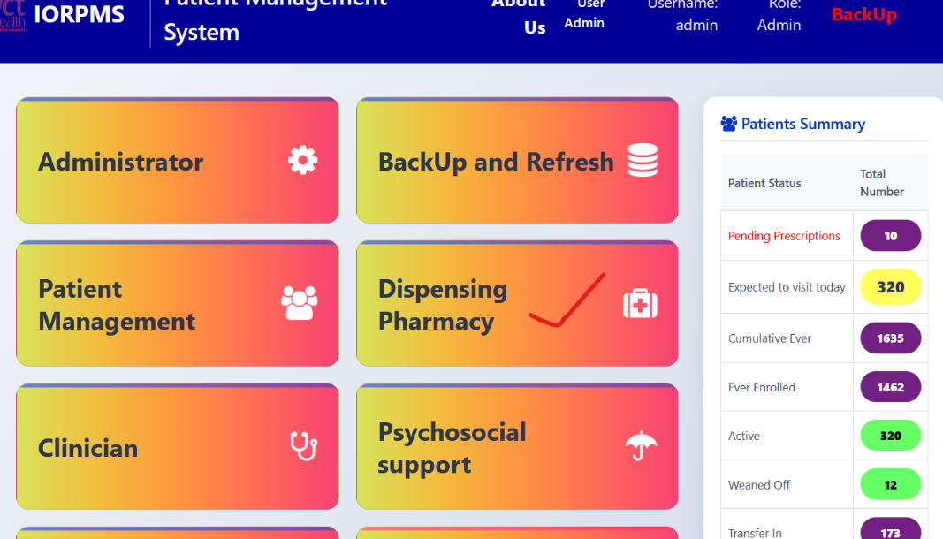 1. Click on **Dispensing Pharmacy**

2. Click on **Pump Reservoir** on the sidenav

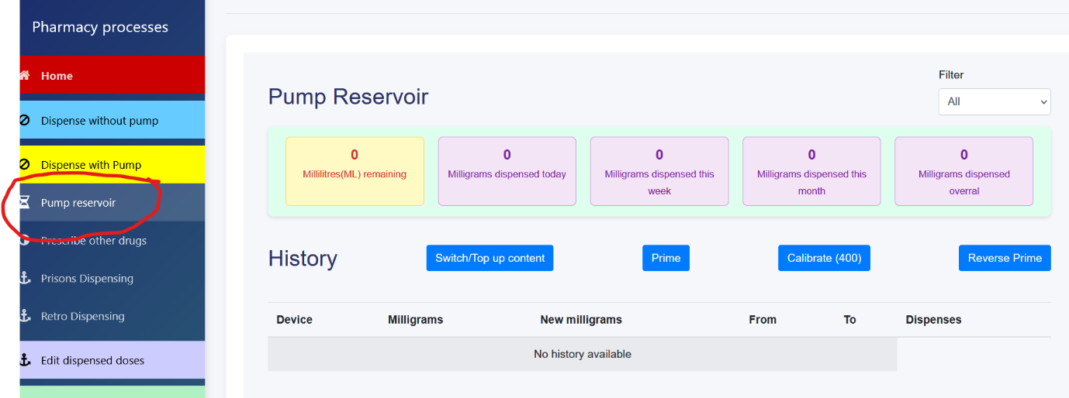

3. Click “Prime” button to fill pump tube with dispensing drug

NB. Repeat priming until drug dispenses to the target container. If pump unresponsive, use

“Reverse Prime” button to initiate the pump or empty drug from the tube

4. If drug completely fills the tube, prime once on an empty tumbler/container, measure the

dispensed volume and measure to determine its quantity in millimetres.

5. Click on “Calibrate (#)” button and enter the dispensed volume in the prompt as shown below

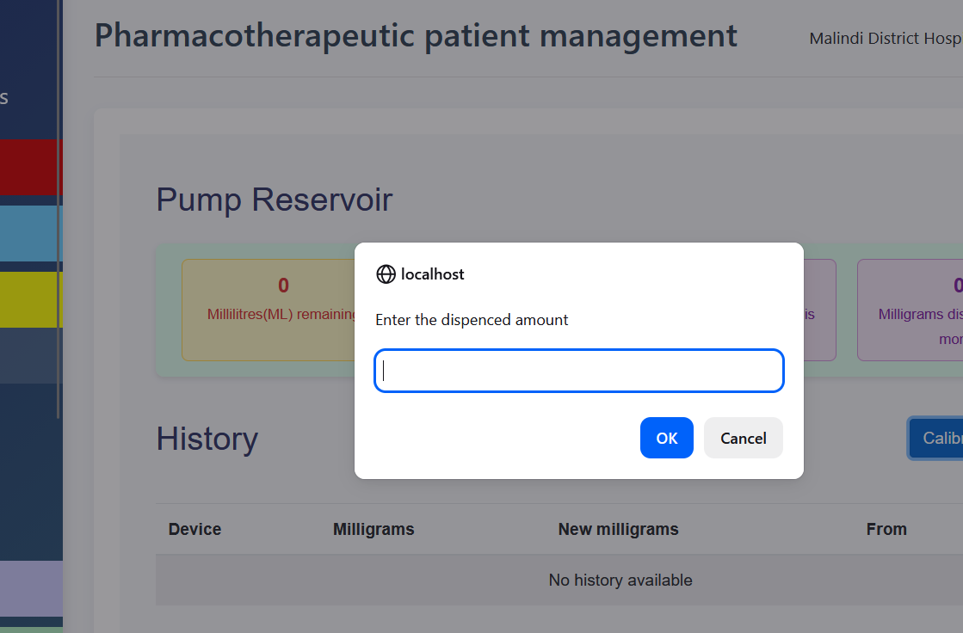

Now you can proceed to normal dispensing procedure after calibration.

NOTE: **It’s highly advisable that priming and calibration be done everyday before first client is served**

**6. USING MULTIPLE PUMPS**

Where two more pumps are available in a facility, they can all be connected to the hosting machine (server) and configured to be used simultaneously. Each pharmacist should be assigned to one pump closer to him/her.

All pumps with associated ports are configured once by a technician during pump installation where pump names/labels with associated PORT identities are entered manually into a database table (pump-devices) for system users to select from.

**When/where pump selection is mandatory:**

1. **Top-up contents**

This is done to replenish the pump reservoir quantity/volume in system database. It is a mandatory procedure done anytime the volume in the pump-reservoir decreases slightly below the volume to be dispensed, on which the system redirects user to top-up reservoir as shown below.

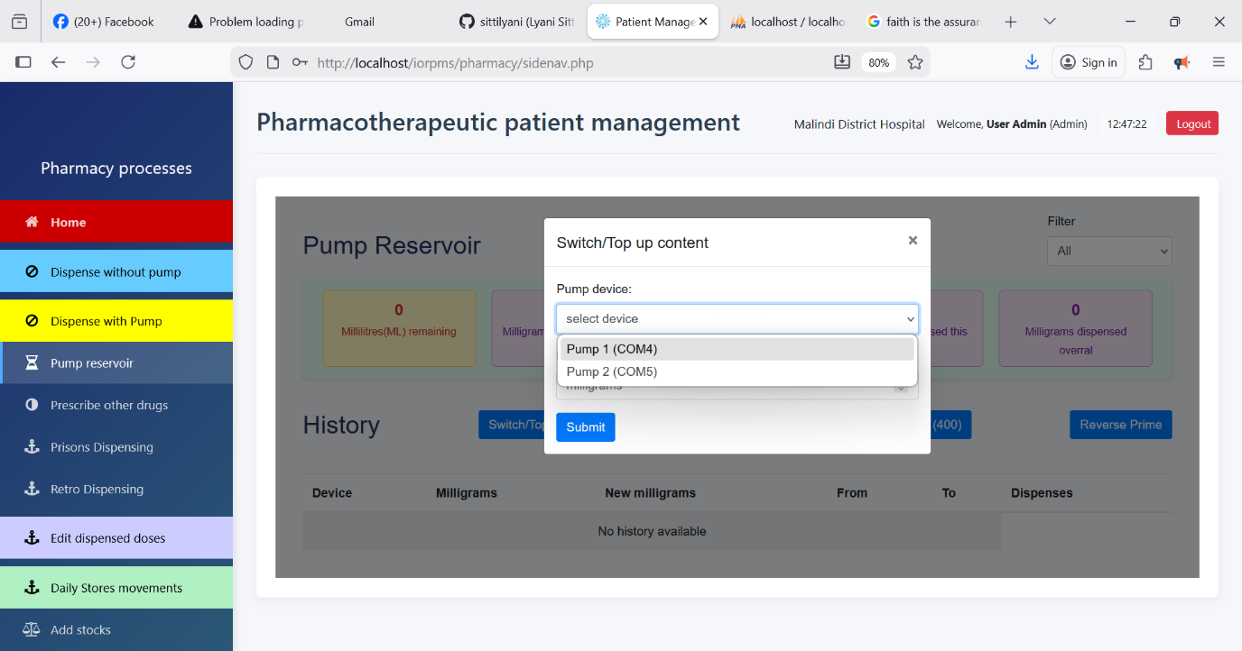

1. On **Pump Reservoir**, click **switch/top-up content** button
2. On the prompt, select your target **pump device** to replenish from the select box
3. Enter the quantity in milligrams to be added to pump reservoir then press **Submit**
4. **Actual dispensing**

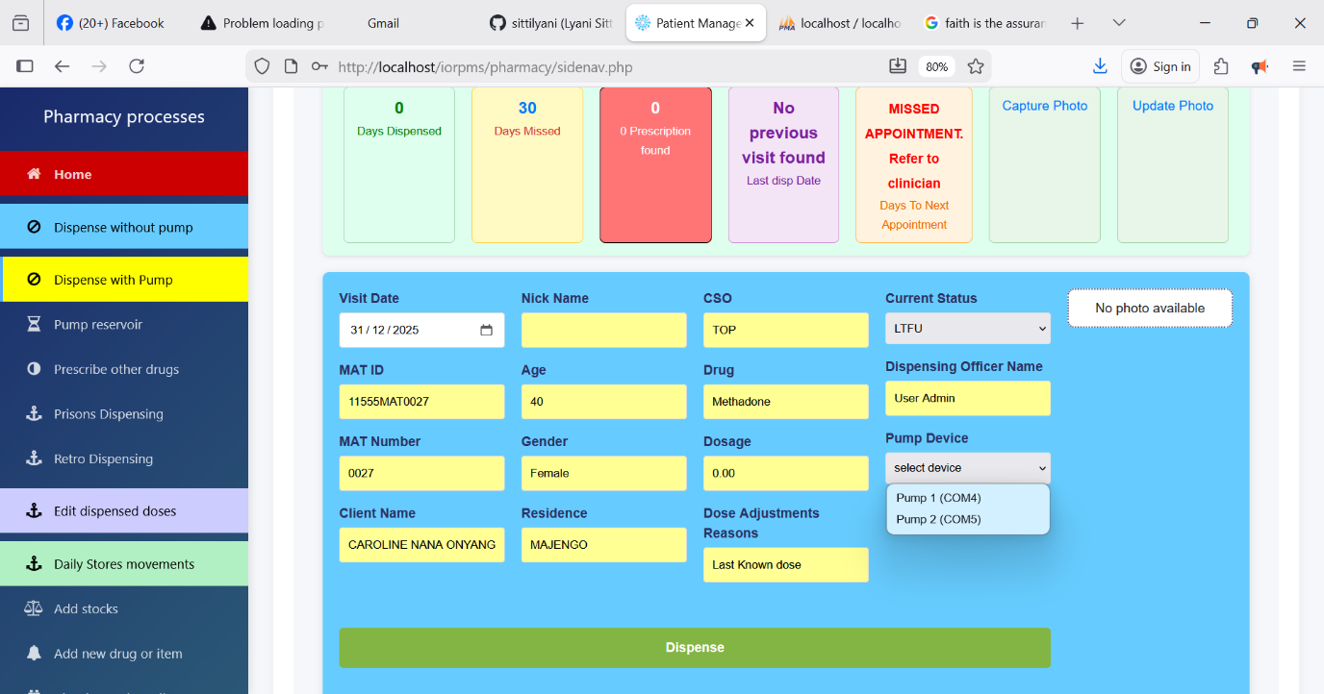

1. On **Dispense with Pump**, search for your desired patient and click **DISPENSE**
2. After system checks, the above window will be displayed with various parameters
3. On **Pump Device** entry, select your target pump from the populated drop-down list
4. When everything is ok, click **Dispense** to discharge the drug with the selected pump

**Note**:

* The system always uses your last **pump device** option unless otherwise changed.
* **Prime**, **Reverse Prime** and **Calibrate** features also use this selected **pump device** option or default and require no pump selection during their use

**PUMP CONTROL API MANUAL**

Pump Control Executable (pump_control.exe)

**Overview**

pump_control.exe is a command-line executable used to control a **Masterflex - compatible peristaltic pump** via a serial (COM) port. It is intended for use in **production environments**, including integration with PHP, JavaScript, or other systems that can execute EXE files.

The executable communicates with the pump over RS‑232/USB serial communication and returns **JSON-formatted responses** for easy integration.

**Key Features**

* Dispense a specified liquid volume
* Support for different tubing sizes (L/S14, L/S8)
* Speed scaling (percentage-based)
* Direction control (forward / reverse)
* Calibration system stored in JSON
* Raw command passthrough
* Emergency stop command
* JSON output (success/error)

**System Requirements**

* Windows 10 or later
* Available COM port (USB-to-Serial or RS‑232)
* Pump drivers properly installed

**Files Included**

* pump_control.exe – Main executable
* calibration.json – Auto-created calibration file (same folder)

⚠️ **Do not delete** the calibration file once created.

**General Command Syntax**

pump_control.exe <COM_PORT> <BAUD_RATE> <action> [parameters]

**Actions & Usage**

**1. DISPENSE**

Dispenses a specified volume of liquid.

**Syntax**

pump_control.exe COM13 9600 dispense <volume_ml> <tubing> <direction> [speed_percent]

**Parameters**

|  |  |
| --- | --- |
| **Parameter** | **Description** |
| volume_ml | Volume in milliliters |
| tubing | L/S14 or L/S8 |
| direction | f = forward, r = reverse |
| speed_percent | Optional (default = 100) |

**Example**

pump_control.exe COM11 9600 dispense 25 L/S14 f 150

**2. CALIBRATE**

Stores an accurate calibration factor for a tubing type.

**When to use**

* After tubing change
* For high-precision dispensing

**Syntax**

pump_control.exe COM13 9600 calibrate <tubing> <measured_ml> <steps_used>

**Example**

pump_control.exe COM13 9600 calibrate L/S14 9.85 12000

This creates/updates:

{ "L/S14": 0.0008208333 }

**3. RAW COMMAND**

Sends a raw command directly to the pump.

**Syntax**

pump_control.exe COM13 9600 raw "/1V1200L500R"

Use with caution ⚠️

**4. STOP (EMERGENCY HALT)**

Immediately stops pump movement.

**Syntax**

pump_control.exe COM13 9600 stop

**Output Format (JSON)**

All responses are returned as JSON.

**Success Example**

{

"success": true,

"response": "OK",

"steps": 12000,

"tubing": "L/S14"

}

**Error Example**

{

"success": false,

"error": "Access denied to COM port"

}

**Tubing Presets**

|  |  |  |
| --- | --- | --- |
| Tubing | Default Speed (V) | Load (L) |
| L/S14 | 1200 | 500 |
| L/S8 | 1800 | 900 |

Speed scaling is applied using the optional percentage argument.

**Integration Examples**

**PHP**

$cmd = "pump_control.exe COM13 9600 dispense 10 L/S14 f 120";

$output = shell_exec($cmd);

$response = json_decode($output, true);

**JavaScript (Node.js)**

const { exec } = require('child_process');

exec('pump_control.exe COM13 9600 stop', (e, out) => console.log(out));

**Safety Notes**

* Always test with **water** before chemicals
* Start at low speeds
* Never exceed pump mechanical limits
* Ensure correct tubing size is selected

**Troubleshooting**

|  |  |
| --- | --- |
| **Issue** | **Solution** |
| No response | Check baud rate |
| Access denied | Close other serial apps |
| Wrong volume | Run calibration |
| Motor stalls | Reduce speed or load |

**5. PRIME/REVERSE PRIME AND CALIBRATION**

This feature is critical as it ensures that the pump dispenses the correct volumes of drugs even with wear and tear of the pump tube.

 1. Click on **Dispensing Pharmacy**

2. Click on **Pump Reservoir** on the sidenav



3. Click “Prime” button to fill pump tube with dispensing drug

NB. Repeat priming until drug dispenses to the target container. If pump unresponsive, use

“Reverse Prime” button to initiate the pump or empty drug from the tube

4. If drug completely fills the tube, prime once on an empty tumbler/container, measure the

dispensed volume and measure to determine its quantity in millimetres.

5. Click on “Calibrate (#)” button and enter the dispensed volume in the prompt as shown below



Now you can proceed to normal dispensing procedure after calibration.

NOTE: **It’s highly advisable that priming and calibration be done everyday before first client is served**

**6. USING MULTIPLE PUMPS**

Where two more pumps are available in a facility, they can all be connected to the hosting machine (server) and configured to be used simultaneously. Each pharmacist should be assigned to one pump closer to him/her.

All pumps with associated ports are configured once by a technician during pump installation where pump names/labels with associated PORT identities are entered manually into a database table (pump-devices) for system users to select from.

**When/where pump selection is mandatory:**

1. **Top-up contents**

This is done to replenish the pump reservoir quantity/volume in system database. It is a mandatory procedure done anytime the volume in the pump-reservoir decreases slightly below the volume to be dispensed, on which the system redirects user to top-up reservoir as shown below.

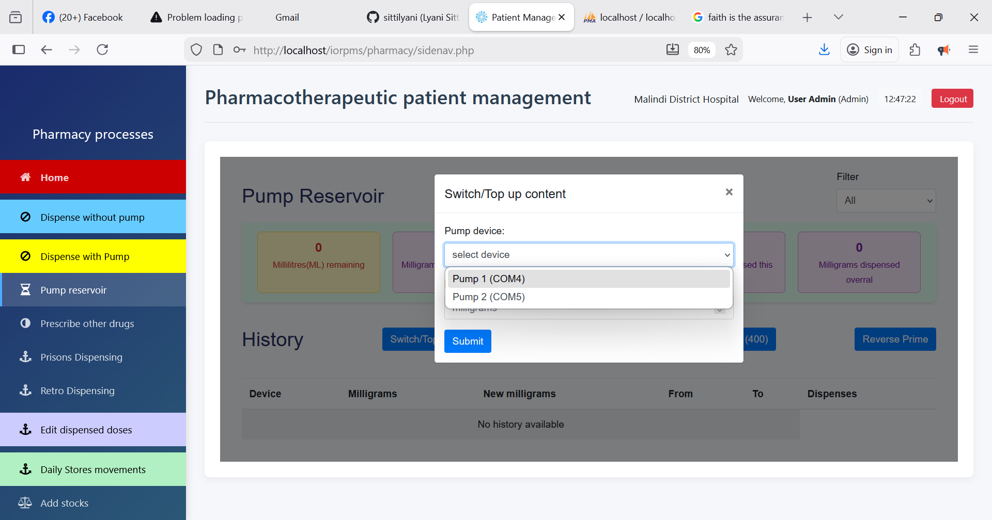

1. On **Pump Reservoir**, click **switch/top-up content** button
2. On the prompt, select your target **pump device** to replenish from the select box
3. Enter the quantity in milligrams to be added to pump reservoir then press **Submit**
4. **Actual dispensing**

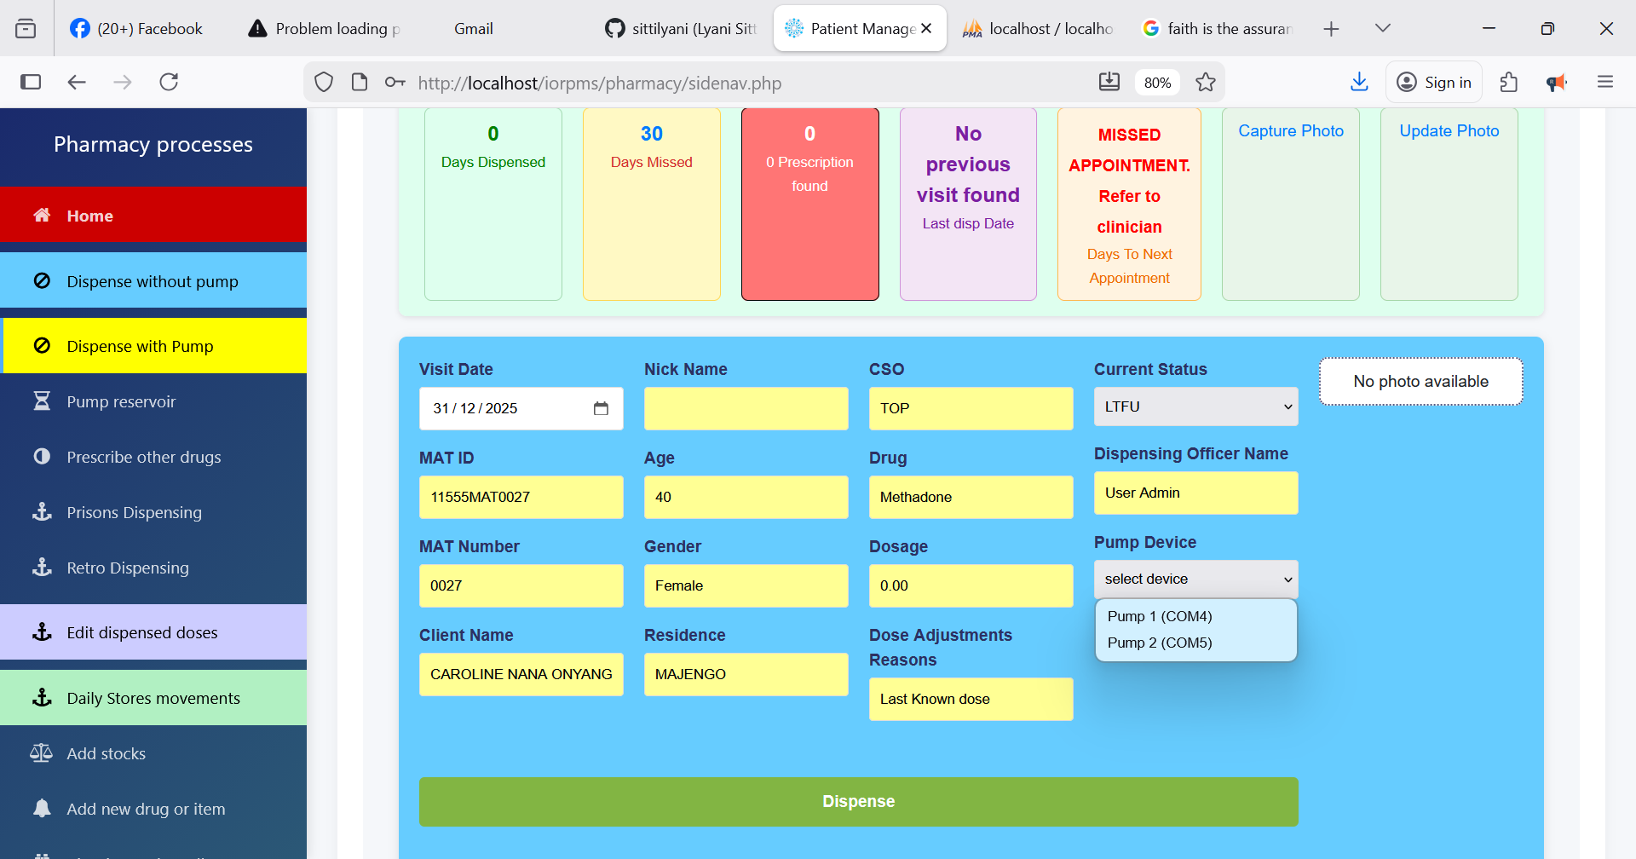

1. On **Dispense with Pump**, search for your desired patient and click **DISPENSE**
2. After system checks, the above window will be displayed with various parameters
3. On **Pump Device** entry, select your target pump from the populated drop-down list
4. When everything is ok, click **Dispense** to discharge the drug with the selected pump

**Note**:

* The system always uses your last **pump device** option unless otherwise changed.
* **Prime**, **Reverse Prime** and **Calibrate** features also use this selected **pump device** option or default and require no pump selection during their use